AWS Solutions Architect Associate

Heading 1: Block in the course.
Heading 2: Chapter in the block.
Heading 3: Different topics in the chapter.
[EXAM-QUESTION]: Look up, possible exam question

Course Scenario
Animals4Life
- Animal rescue and awareness organization
- Depending on the region, they’re involved with local animal rescue and medical care, and rehoming domestic animals or habitat work for wild animals.
- Monitor animal migration, habitat disruption, etc.
- Their work involves IoT and Data sets.
- They are a GLOBAL company, with HQ in Brisbane Australia – 100 staff (call center, admin, it marketing, legal & accounts)
- 100 remote workers across Australia and Globally.
- Major offices in London, NY and Seattle.
Infrastructure:
- Small on-permises datacenter in Brisbane where they rent 5 racks of space.
- Data center is old, and they’re being encouraged to migrate ASAP.
- Global Offices & mobile staff utilize Brisbane infrastructure.
- Cost-conscious but progressive management team (opened to new technologies).
Head Office:
- On-premise: 192.168.10.0/24
- AWS Pilot: 10.0.0.0/16
- Azure Pilot: 172.31.0.0/16
London, NY and Seattle consume the IT services provided by the head office (less than ideal from a performance perspective).
They employ several field workers that use laptops, 3, 4G and satellite connection, data u/l & d/l, email, file access, Chat & planning and Research datasets.
Current Problems
- Legacy on-premises hardware is failing.
- AWS/Azure pilots have been messy and not best practice.
- Performance issues for field workers. Best case scenario the performance is poor, worse case scenario the system is in maintenance at night in Briston, but in peak hours of work in London and North America.
- Lack of Highly Available and Scalable systems.
- Small IT team with struggles in automation.
- Global expansion concerns, cost for new infrastructure.

Ideal outcomes
- Fast performance for all field workers.
- Able to deploy into new regions quickly when required. Ideally, it’ll be achieved whenever needed in a Pay as needed system.
- Low cost & scalable base infrastructure.
- Agility – spin up new marketing campaigns, social and progressive applications (IoT, Big Data, etc).
- Automation – low base staffing costs.

Contents
Course Scenario 1
Course Fundamentals and AWS Accounts 7
Basics 7
Account 7
Security 7
Creating an AWS Account 7
Create multiple accounts with one email 7
Multi-Factor Authentication (MFA) 8
Securing an AWS Account 8
Creating a Budget 8
Identity and Access Management (IAM) Basics 8
Adding an IAM Admin 9
IAM Access Keys 10
Creating Access Keys 10
Cloud Computing Fundamentals 11
What is Cloud Computing 11
Public VS Private VS Hybrid VS Multi Cloud 11
Cloud Service Models 12
Tech Fundamentals 13
YAML Ain’t a Markup Language 13
JavaScript Object Notation 14
Encryption 14
Encryption Approaches 14
Concepts 14
Signing 15
Steganography 15
Networking 15
Intro 15
Layer 1 – Physical 17
Layer 2 – Data Link 17
Layer 3 – Network 18
IP Addressing 19
Address Resolution protocol (ARP) 19
Routing 20
Summary 20
Layer 4 – Transport (and some Layer 5) 20
Network Address Translation (NAT) 23
IP Addressing & Subnetting 23
Private IP Addresses 23
Subnetting 24
DDoS 24
SSL and TLS 24
Hashing 25
Digital Signatures 26
DNS 101 26
What it does 26
Key Terms 26
Hierarchical Design 26
What do we want from DNS? 26
Registering a DNS Domain 27
DNSSEC 27
Recovery Point Objective (RPO) 29
Recovery Time Objective (RTO) 29
AWS Fundamentals 31
Public VS Private Services 31
AWS Global Infrastructure 31
AWS Region 31
AWS Edge Location 32
How to define the resilience of an AWS Service 32
Virtual Private Clouds (VPC) Basics 32
VPC Architecture and Default VPC 33
Elastic Compute Cloud (EC2) Basics 33
Amazon Machine Image (AMI) 34
Connecting to EC2 instances 35
Launching EC2 instances 35
S3 Basics 35
Objects 35
Buckets 35
Good and bad applications of S3 36
[DEMO] Creating an S3 Bucket 36
CloudFormation Basics 37
CloudFormation Demo 38
CloudWatch Basics 38
Namespace 39
Metric 39
Datapoint 39
Dimension 39
Alarm 39
Shared Responsibility Model 40
High Availability (HA) vs Fault Tolerance (FT) vs Disaster Recovery (DR) 40
High Availability 40
Fault Tolerance 40
Disaster Recovery 41
Summary 41
Route53 Fundamentals 41
Route53 zones 42
DNS Record Types 42
NameServer (NS) 42
A and AAAA Records 43
CNAME Record 44
MX Record 44
TXT Records 45
DNS TTL (Time To Live) 45
Review Questions 47
IAM, Accounts and AWS Organizations 51
IAM Identity Policies 51
Inline policies 52
Managed Policies 52
IAM Users 52
Amazon Resource Names (ARNs) 53
EXAM POWER-UP 53
IAM Groups 53
IAM Roles 53
Trust Policy & Permissions Policy 54
When to use IAM Roles 54
Service Linked Roles 55
AWS Organizations 55
Creating the AWS account structure 56
Service Control Policies 58
Deny List 58
Allow List 58
Using SCP 58
CloudWatch Logs 59
CloudTrail Essentials 60
IMPORTANT 60
Summary 61
Implementing an Organizational Trail 61

Course Fundamentals and AWS Accounts

Basics
Simple systems may operate within one account, but more complex systems may use 10ths or 100ths AWS accounts. But what is an account?

Account
An account (AWS Account) is a container for identities (users) and Resources. Identities is the technical correct way to refer to users, the things you use to log in to systems such as AWS.
When you create an Account, you provide an account name: Name, unique email address and credit card.
Every account has an Account Root User, that comes from the email. Initially, that is the only user created with an AWS Account. This user has full control over all the account and resources, and it can’t be restricted.
If any of the resources used are to be billed, they will be billed to the Account Payment Method (Credit Card).

Security
Account Root User has full control over its own account. Additional identities can be created, and these can be restricted. To do this, we use IAM.
Identity and Access Management (IAM) Users, Groups and Roles can be given full or limited access rights.
Accounts have boundaries. These boundaries can contain the impact of admin errors or exploits by bad actors. Use separate accounts for separate things (Dev, Test, Prod) or teams or products or clients.
By default, all access to an account and its resources is denied except for the root user.

Creating an AWS Account
General Account (Management): Account I will log in into with the root user. Root user will have full control. After creating it, MFA (Multi-Factor Authentication) will be added. After that, a budget will be created for control. It will notify us if we go over.
After, within the general account we will create an IAM account named IAMADMIN (because root cannot be restricted).
Production Account: After the General Account is created, a second account will be created. This second account will be called Production, and we will follow the previous steps.

Create multiple accounts with one email
In GMAIL and other providers (mark.ene@gmail.com) I can add the ‘+’ symbol after my email name to create several accounts, e.g:
mark.ene+AWSAccount1@gmail.com
mark.ene+AWSAccount2@gmail.com
After having created the account, go to:
Account (dropdown menu on the top right corner) -> IAM User and Role Access to Billing Information -> Edit -> Check Activate IAM Access and click Update.
This will make sure if you’re logged as an IAM user, you will have access to billing box if you’re given permission.

Multi-Factor Authentication (MFA)
Factors: Different pieces of evidence which provide identity. There are different types of factors, hence the Multi. Some of them are:
- Knowledge: Something you know; usernames, passwords…
- Possession: Something you have; bank card, MFA device/app
- Inherent: Something you are; fingerprint, face or voice identification
- Location: A physical location or type of network (corporation VS home network).
More factors mean more security.

Securing an AWS Account
To attach an MFA device:
- Dropdown menu right corner -> Security Credentials -> Multi-factor Authentication -> Activate MFA.
- After, scan QR code and introduce two consecutive different codes.

Creating a Budget
aws.amazon.com/free
Dropdown menu -> Billing Dashboard:
- Billing Preferences: Get notified of the bills.
- Budgets: Monitor spend and configure alerts.
- Cost explorer: Budgets are limited, these need to be enabled.

Identity and Access Management (IAM) Basics
Why create several IAM? Root has full unrestricted access to the account. The account and the account root user are basically the same. In the real world, you will need to grant access to other people to the account. It is always BEST PRACTICE to only give the permissions required to do a job. This is called least privilege access.
Every AWS Account comes with its own copy of IAM; its own database. This is a globally resilient service, so all its data is always secure thorough all AWS regions. [EXAM-QUESTION]
Your AWS account trusts your instance of IAM, and like root-user, can do anything in the account. There are only some restrictions around billing control and account closure.
There are three different types of identity objects:
- IAM User: Humans or applications that need access to the account. Someone needs access to terminate a Virtual Machine.
- IAM Group: Collection of related users, e.g. Development team, finance or HR.
- IAM Role: Can be used by AWS Services or granting external access to the account. They tend to be used when the number of things is uncertain.
Policies allow or deny access to AWS Services.
IAM has three main jobs:
- Manages Identities – an ID Provider (IDP).
- Authenticate those identities.
- Authorize.
Some characteristics:
- No cost for creating users, groups or roles. There are some details.
- Global service (one global database) and it is globally resilient (can cope with failures).
- Allow or deny its identities on its AWS account.
- No direct control on external accounts or users.
- Lets you use Identity federation (let’s you use identities you already have, like facebook) and MFA.

Adding an IAM Admin
In general, we don’t want to use the root user. After creating an AWS Account, the first thing that should be done is to create an Admin user. I need a specific sign-in URL for IAM users in the account.
We need to setup an account alias that is globally unique, which will be the first part of the URL.
To create an IAM new user:
- Users -> Add users. Username: iamadmin (only needs to be unique within the account).
- Select type of access.
- After, we have to set permissions. The user can be added to an existing group which already has permissions or permissions could be copied from an existing user. If none work, we have to “Attach existing policies directly”.
  - AdministratorAcces: Grants full admin control over the AWS account
- Finally, we need to check if it worked. Use the special sign-in URL link to try to login as the newly created user.
- We need to, once again, set up MFA since this is done for each user individually.

IAM Access Keys
To access the console through the CLI or APIs or other applications.
Access keys are a long-term credential available in AWS. An IAM user can have two access keys, and these can be created, deleted, made active or inactive. They are formed by two parts:
- Access Key ID (public).
- Secret Access Key (private).

Creating Access Keys
aws configure --profile profileName
Insert public and private key, as a region North Virginia is “us-east-1” and for output leave empty.
Run aws s3 ls --profile profileName and if it returns an empty string (in the case there are no S3 buckets) it means it worked.

Cloud Computing Fundamentals

What is Cloud Computing
There is a set of five characteristics that a system must be considered cloud:
- On demand self-service: Cloud can provision capabilities (features or products such as VM, databases, network…) as needed without requiring human interaction (you don’t need to inform anyone in advance, AS NEEDED).
- Broad network access: Capabilities are available over the network and accessed through standard mechanisms that provide use by heterogeneous thin or thick client platforms (phones, tablets, laptops, workstations…) Capabilities are available over the network and accessed through standard mechanisms.
- Resource pooling: There is a sense of location independence, no control or knowledge over the exact location of the resources. Abstraction and economies of scale, you want a VM in a certain region but they’re free to use any data center they want. Resources are pooled to serve multiple consumers using a multi-tenant model. They’re free to use whatever vendor they want. Storage, processing, memory, network bandwidth.
- Rapid elasticity: Capabilities (resources) can be elastically provisioned and released to scale rapidly outward and inward with demand. To the consumer, the capabilities available for provisioning often appear to be unlimited. Systems which scale in size in response to load.
- Measured Service: Resource usage can be monitored, controlled, reported and billed.
[EXAM-QUESTION]
- On-Demand Self-Service -> Provision and Termination using a UI/CLI without human interaction.
- Broad Network Access -> Access services over any networks on any devices, using standard protocols and methods.
- Resource Pooling -> Economies of scale, cheaper service.
- Rapid Elasticity -> Scale UP (OUT) and DOWN (IN) automatically in response to system load.
- Measured Service -> Usage is measured. Pay for what you consume.
If a solution meets all of these characteristics, is Cloud.

Public VS Private VS Hybrid VS Multi Cloud
Multi-Cloud is using multiple Cloud environments (e.g. Azure, AWS and Google). The problem with multi-cloud is that if a service is offered in both, (Azure and AWS for example) only the ‘more generic’ service would be useful.
AWS Outposts is the public cloud AWS offers. A private cloud still needs to meet the 5 characteristics, but it is dedicated to one client as a business.
In summary:
- Public Cloud needs to use 1 public cloud (AWS, Azure, Google…)
- Private Cloud needs to be using on-premises cloud.
- Multi-Cloud needs to use more than 1 public cloud.
- Hybrid Cloud needs public and private clouds, generally from the same vendor.
- Hybrid cloud is not public cloud + legacy on-premises. That is a hybrid environment or a hybrid network.
[EXAM-QUESTION]

Cloud Service Models
Something as a Service.
When you deploy an app anywhere it uses an Infrastructure Stack (Facilities, Infrastructure, Servers, Virtualization, O/S, Container, Runtime, Data, Application) which is a collection of things which that application needs, stacked onto each other. Starting at the bottom, (an app) everything happens in a building (facilities), everything uses infrastructure (storage and network), it generally requires one or more server (servers, virtualization) which run VM (O/S) which can be containerized, apps are written in a language (runtime), it uses data and finally there is the application.
Some parts are managed by me, some other are managed by the vendor.
A Unit of Consumption is what you pay for and it is what you consume, e.g., if you procure a Virtual server, your union of consumption is a VM, which is an O/S and an allocation of resources, so the unit of consumption is the OS.
In the case of On-Premises, businesses own and control everything, which is expensive and carries some risks.
- On-Premises: you own everything in the Infrastructure Stack.
- DC Hosted: you rent the facilities, own everything else.
- Infrastructure as a Service: you manage everything under the O/S (virtual machine, EC2)
- Platform as a Service: Something like Heroku, you provide the runtime and it gets deployed.
- Software as a Service: Office 365.
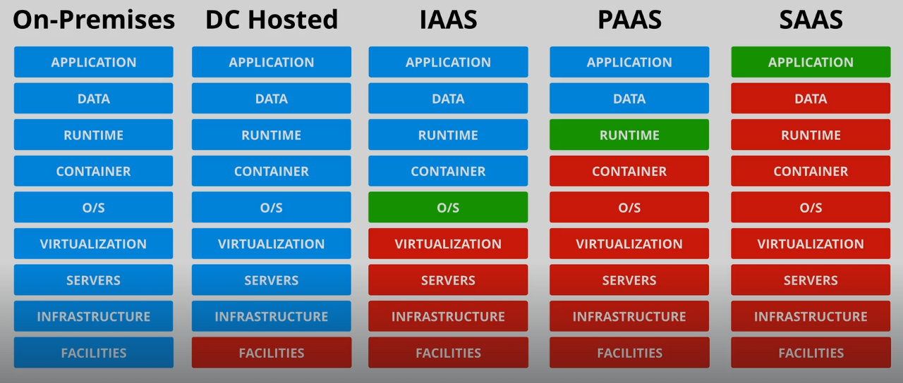

Tech Fundamentals

YAML Ain’t a Markup Language
YAML stands for YAML Ain’t Markup Language (Y for YAML). It is a human-readable language for data serialization. At a high level, it is a unorder collection of key/value pairs. It supports lists (ordered set of values) and arrays.
List:
listName: [“value1”, “value 2”, “value 3”] // inline
listName2:
- “value 1”
- “value 2”
- “value 3”
Indentation really matters. It is always done using spaces, and same level of indentation means that the things are in the same structure. The ‘-‘ (hyphen) means each item is a member of a list, same indentation = same list. Lists can be nested in lists.
Dictionary: Collection of key-value pairs which are unordered.
Dictionary:
- name: roffle
color: [black, white]
- name: truffles
color: “mixed”
- name: penny
color: “grey”
numofeyes: 1
This dictionary has a key of “Dictonary” and the value of a list with several key-value pairs.

JavaScript Object Notation
Other than Cloud, policies for example also use JSON. It has a similar structure as YAML.
It is a lightweight data-interchange format. It is easy for humans to read and write and it is easy for machines to parse and generate.
In JSON arrays are lists in YAML. Values can be; string, object, number, array, boolean (true or false) or null. JSON documents are JSON objecets.

Encryption

Encryption Approaches
There are two main approaches:
- Encryption at Rest. It is used to protect against physical theft and physical tampering. A common example of this is a user with an encrypted laptop with a secret or password. This is usually used in Cloud environments. The user’s data is stored in hardware, in an encrypted form.
It is generally used when only one party is involved, and that party is usually the only one knowing the secret or password.
- Encryption in Transit. It is aimed at protecting data while it is being transferred between two places, for example banking. Generally used when multiple systems or individuals are involved.

Concepts
- Plaintext: Un-encrypted data, it can be text but it doesn’t have to be (it can be images or apps).
- Algorithm: Piece of code which takes plain-text and an encryption key and it generates encrypted data. Common examples are Blowfish, AES, RC4, DES, RC5 and RC6.
- Key: At its simplest it is a password. The type of key influences how encryption is done:

Symmetric
The same key is used for both encryption and decryption processes. It is not useful for situations where data must be transferred between two remote parties. It is good for local operations.

Asymmetric
They are formed of two parts; public and private key. Both sides need to make a public and a private key in order to be able to send data to each other. The private key is the key used to decrypt the data, so it must be securely stored. The public key is used to encrypt and that is as much as it can be done with it.
One party uploads the public key to the cloud storage so anyone can access it. The party that wants to send data will download the public key and encrypt the data with it. The other party will receive the ciphertext (safe to transfer over any network) encrypted by their public key and use their private key to decipher the ciphertext encrypted with his own public key by the other party.
It is computationally much more difficult to do than Symmetric.
- Ciphertext: Result of an algorithm taking plaintext and a key. It is encrypted data.

Signing
The problem with asymmetric is that anyone can encrypt data and send fake messages to a party. Encryption does not prove identity. To authenticate the origin of a message, it can be signed using a private key, and then the public key can be used to authenticate the origin of that message. At no point is the private key revealed.

Steganography
Sometimes encryption isn’t enough. The problem if encryption was used, it is obvious. Steganography is a process that addresses this. For example, using invisible ink that only shows when heated or with certain light.
For example, the data can be sent as a puppy image.
Let’s say we want to hide a ‘Hi’ message. The values of ‘H’ and ‘I’ are 8 and 9. The steganography algorithm would get the puppy image, select two random pixels and change their bright by those values, creating an almost identical image.

Networking

Intro
Any interaction with AWS involves networking. Networking may refer to local, global and application.
- Local networking: How data moves between devices on a local network.
- Routing: How data moves across the internet. When data moves across the internet, it moves across many interconnected networks.
- Segmenting, ports & sessions.
- Applications
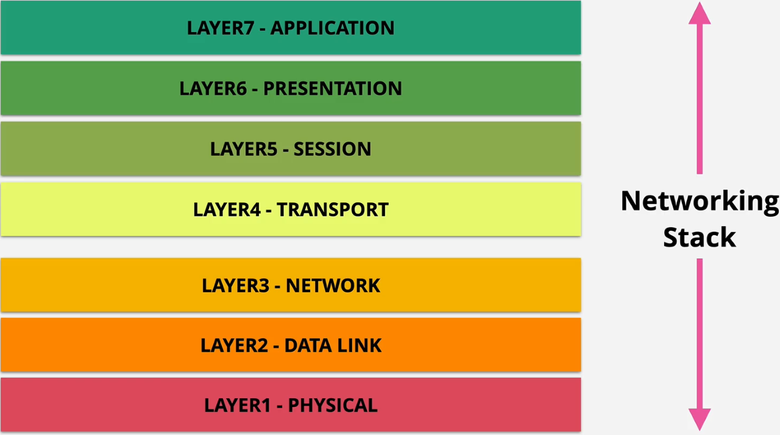
- OSI 7-Layer Model:

Layer 1, 2 and 3 are the Media Layers, and it deals on how the data is transported. Host layers are 4-7, and they deal with how to adapt and organize the data to send it.

Layer 1 – Physical
The physical medium is a connection between two machines in a network. It can be Copper (electrical), Fibre (light) or Wifi (Radio Frequency). Whatever type of medium is used, it needs a way to carry unstructured information. For this, there are layer 1 standards or specifications, which define how to receive bit streams.
To connect more than one by Copper, we need Hubs; these transmit anything received on any port to every other port.
In this layer there is no direct communication with other machines, everything transmitted is heard by everyone. A collision occurs when two devices try to transmit at once. Layer 1 has no media access control and no collision detection.

Summary
Physical shared medium, Standards for transmitting onto the medium and receiving from the medium. No access Control, No uniquely identified devices, no device = no communications.

Layer 2 – Data Link
Supports the transfer of the data. L2 introduces Frames. Frames are a format for sending information over a Layer2 Network. It also introduces a unique hardware address (MAC) for every device on a network, which is 48 bits long (3e:22:3b:ff…)
A MAC Address is formed of two parts:
- OUI: Organizationally Unique Identifier, assigned to companies who manufacture network devices.
- NIC-specific: Network Interface Controller, second part who is unique.
A Frame has also different components:
- Preamble: Start of the Frame delimiter. 56 Bits, SFD – 8 bits.
- Destination MAC Address: Every frame has a destination. If destination MAC Address is all network, it can be completed with all f’s (ff:ff:ff…), which is known as a broadcast.
- Source MAC Address: Set to the device address who is transmitting the frame, allows to receive replies.
- EtherType (ET), 16 bits: Allows us to specify which L3 protocol is putting its data inside a frame.
- Payload, 46-1500 bytes: Contains the data being sent by the Frame.
- Frame Check Sequence (FCS): Allows to identify any errors in the frame, CRC check. Has corruption occurred?
CSMA Carrier Sense Multiple Access detects if there are any devices in the network are transmitting (Carrier). The other end receives the package through Layer 1, and it passes it to its Layer 2, which reads the frame and sees that it is destined to its MAC address.
Encapsulation: Process of taking some data and wrapping it in something else.
Layers are independent (conceptually), so they talk to each other. Anything below the point you are communicating with (any layers) are abstracted away. For example, two servers communicating at Level 7 are communicating at that level, ignoring the rest (servers talk to each other, they go through every level in the OSI or TCP/IP model, but conceptually they communicate directly).
If a collision is detected (CD) a jam signal is sent and a random back off occurs. A back off is a period of time when no device will attempt a transmission.
The difference between a Hub and a Switch is that a Hub is a Layer 1 device (doesn’t interpret the raw data) and a Switch it is a Layer 2, so it has Layer 2 software running inside, which means it understands L2 (frames). It maintains what is called a ‘MAC Address Table’ which starts off empty. As the switch receives frames on its ports, it learns which devices are connected and populates the MAC address table. A switch can interpret where the frames are destined.
Switches store and forward frames, they don’t repeat blindly like hubs. It means that only valid frames are forwarded – collisions are isolated on the port they occurred. Every X port switch has X collision domains. It allows switches to scale and be connected together.

Summary
- Identifiable devices.
- Media access control (sharing access to physical media).
- Collision detection
- Unicast communications 1:1
- Broadcast communications 1:all
- Switches store and forward so we avoid collisions.

Layer 3 – Network
Common protocol which can span multiple Layer 2 protocol networks. It adds IP (Internet Protocol) which adds cross-network IP addressing and routing to move data between Local Area Networks without direct P2P links.
IP Packets are moved step by step from source to destination via intermediate networks, encapsulated in different frames along the way.
Routers (L3 devices) remove frame encapsulation and add new frame encapsulation at every hop.
With LAN destination address are typically local. With IP the destination and source address can be in opposite sides of the planet.

IPv4
As a summary of the most important parts, every packet has:
- Source IP Address
- Destination IP Address
- Protocol field: Generally contains data provided by another Layer (L4) and this field stores which protocol is used (ICMP, TCP, UDP).
- TTL (Time To Live): Packets move through many different intermediate networks between source and destination. This value defines how many hops the packet can move through, and stops packets from moving forever.
- Data.

IPv6
It has the same basic fields as v4 except TTL is now Hop Limit.

IP Addressing
IP Addressing is what identifies a device which uses Layer 3 IP Networking. Every IP(v4) address is 32 bits (4 bytes) – 4 x 8 bits (octets) and it has two parts:
X:X:Z:Z
- X:X -> Represent the network the IP belongs to.
- Z:Z -> Represents the Host of that IP in the network.
If the network part of two IP addresses match, it means they’re on the same IP network. If a network has a /16 prefix it means that the first 16 bits of the IP are network, and the remaining are for hosts. IP are either assigned by machine (Dynamic Host Configuration Protocol) or by humans.

Subnet Masks
Critical part to IP networking. Subnet Masks are what allow an IP device to know if an IP address is on the same network or not. They are configured on layer 3 interfaces along with IP addresses. Most network interfaces also have a Default Gateway.

Default Gateway
IP address on the local network which packets are forwarded to generally if the intended destination is not a local IP address.

Route Tables – Routes
Router is the process where packets are forwarded, hop by hop across the internet from source to destination.
A route table is a collection of routes. It has ‘destination field’ and ‘next hop/target’ fields. Router compares packet destination IP & route table for matching destinations. The more specific prefixes (number after the slash ‘/’) are preferred (0 lowest, 32 highest). Packet is forwarded on to the Next Hop/Target.

Address Resolution protocol (ARP)
Used generally when you have a L3 packet, and you want to encapsulate it into a frame, and send that frame to a MAC Address, which you initially don’t know and you need a protocol which can find the MAC Address for a given IP address.

Routing
If a Router receives a packet which is addressed somewhere else, its job is to send that packet to its final destination.

Summary
Layer 3 adds:
- IP Addresses (IPv4/6) – cross network addressing.
- ARP – Fin the MAC Address for a given IP.
- Routes, which decide where to forward a packet to.
- Route tables, which contain multiple routes.
- Router – moves packets from source to destination, encapsulating these packets in different L2 frames along the way.
- Allows device to device communication over the internet.
- Provides NO method of individual channels of communication. It provides packets, which give source and destination, which means you can only have one directional communication (solved by L4 and above).
- Packets can be delivered out of order, there is no guarantee packets will take the same route, which means data could not arrive in the same order it was sent.

Layer 4 – Transport (and some Layer 5)

Layer 3 Problems
Each packets are independent from each other, even if they carry parts of the same data. This means that every packet is independently routed, which can bring intermittent network conditions, altering the order of the arrival of the packets.
Another issue due to network outages or conditions is the loose of packets, for example exceeding the TTL.
The most notorious issue is that with Layer 3, there are no communication channels; packets have source and destination IP, but no way to differentiate to which application or channel they are going (two different applications running in the same computer).
Lastly, IP has no flow control. If the src transmit faster than destination can receive, it can saturate the destination causing packet loss.
Layer 4 solves all these problems. It adds TCP and UDP, running on top of IP. You’d pick TCP when you want reliability, error correction and order of data. It is slower but more reliable. It is used for SSH, HTTP, HTTPS and so on. It is a connection-oriented protocol, which means you have to setup a connection between two devices and once set up. UDP is faster because it doesn’t have the TCP overhead for reliability.
They both however, run on top of IP and they’re used as transit. UDP is performance, TCP is reliable.

TCP/IP
TCP is a connection based protocol. A connection is established between two devices using a random port on a client and a known port on the server. Once established the connection is bi-directional, the “connection” is a reliable connection, provided via the segments encapsulated in IP Packets.
TCP introduces ‘segments’: Segments are container for data (like packets and frames), but segments are specific to TCP. These are encapsulated (contained) within IP packets. Segments don’t have source or destination IP addresses because they use the IP packets for the transit from source to destination (handled by layer 3). These segments add capabilities to packets.
Some of the important capabilities are:
- Source port: In addition to source and destination IP address, TCP packets add source and dest ports. This gives TCP protocol the ability to have multiple of streams of conversations at the same time between two devices (multiple applications, i.e, browser for HTTPS).
- Destination port:
- Sequence number: Incremented with each segment sent, it is unique and can be used for error correction if things need to be retransmitted, and it can be used to ensure that when IP packets are received and the TCP segments are pulled out, they can be correctly ordered.
- Acknowledgment: Way for one side of comms to indicate that it has received up to and including a certain sequence number.
- Flags ‘n’ Things: Allows various controls over the TCP segments and connections. Flags are used to close the connection or to synchronize sequence of numbers. Things are an extra number of fields .
- Window: Defines the number of bites that you indicate that you are willing to receive between acknowledges. It lets the receiver control the rate at which the sender sends data.
- Checksum: TCP is able to detect errors and can arrange for retransmission of the data as required.
- Urgent Pointer: Pointer to give priority to some part of the communication.
The above fields are known as TCP Header. The remainder of the segment is populated with Data.

How are Segments used in TCP
We need two devices; one of the devices is the client, and the other is the server. The actual communication between Client and Server still uses independent L3 packets and they can be received out of order, with segments encapsulated into IP packets in them.
These segments contain a sequence number, which means that the order of segments can be maintained. If a packet is damaged or lost in transit, even though the segment is lost, it can be retransmitted, guaranteeing delivery.
The client communicates to a TCP port XX in the server (well-known port) from a TCP port YY in the client (random port). Between these two ports, segments are exchanged. This architecturally is now a communication channel. TCP communications are bi-directional, which means the server will send data back to the client (source and destination ports are now reversed). These channels are not real but conceptual.
As part of creating the connection, you also create a port in your local machine, which is temporary. This is known as the Ephemeral port. This tends to use a higher range port and it is temporary (port 80 is well-known port, port 23060 is Ephemeral).

Flags field
- FIN: Will finish a connection
- ACK: Acknowledgment
- SYN: Used at the start of connections to synchronize sequence numbers.
With TCP, you can’t send data without stablishing a connection, both sides need to agree on some starting parameters. This is known as a three-way handshake.
- Step 1: The client needs to send a segment to the server. This segment contains a random sequence number.
  - Send a segment with SYN, set ‘cs’ (ISN) Initial Sequence Number.
- Step 2: The server receives the segment and it needs to respond. Pick the random ISN ‘ss’, send - SYN-ACK segment. Acknowledge is set to ‘cs+1’; this informs the client that it has received up to cs data, now send the rest.
- Step 3: The client receives the segment from the server, it knows the Server Sequence (‘ss’) and to acknowledge to the server that it has received all the information, it takes the Server Sequence and it adds 1 to it, and it puts this number as the Acknowledgement. It also increments its own Client Sequence (‘cs’) by one, and puts that as the sequence. Finally it sends an ACK segment containing all this information through to the server.
- At this point a connection is established and the client can send data. From this point anytime either side sends data, they increment the sequence and the other side acknowledges the sequence value+1, and this allows the retransmission when data is lost.

Sessions & State
There are two types of capability levels that will be encountered from a security perspective:
- Stateless firewall: It doesn’t understand the state of a connection. You need two rules. One allowing the outbound segments, with the initiating traffic, and another one allowing the inbound response server coming in the opposite direction, with the response traffic. In AWS this is what a Network Access Control List is.
- Stateful firewall: It understands the state of the TCP segments. It sees the initiating and response traffic as one thing. If we allow outbound traffic, inbound traffic will be automatically allowed. In AWS this is a Security Group works.

Network Address Translation (NAT)
NAT is used within home and business networks, as well as Cloud Environment. It is a process used to address the growing shortage of IPv4 addresses. It also provides some security benefits. NAT is only used for IPv4 addresses.
The principal problem we face is that public and private addresses cannot communicate over the internet. Private IPv4 addresses are found in private networks such as a home network (with a computer and a server). To communicate and send packets to an API hosted online, we need NAT.
NAT translates private IPv4 addresses to public and vice versa. There is static and dynamic NAT:
- Static NAT: 1 private to 1 (fixed) public address (IGW). The router or NAT device maintains what is known as NAT table with a 1-to-1 device mapping between private IP and public IP.
- Dynamic NAT: 1 private to first available public. Devices are allocated a temporary IP from a pool.

Port Address Translation (PAT) – many private to 1 public (NATGW). Likely used in home network, it allows a large number of devices to share one public IP address. AWS environment. It replaces the source IP with the single Public IP and a unique public source port, allocated from a pool which allows IP Overloading (many-to-one).

IP Addressing & Subnetting
There are five types of IP addresses:
- Class A: First octet denotes network and three other denote host. From 0.0.0.0 to 127.255.255.255.
- Class B: First two octets denote network and two other denote host. From 128.0.0.0 to 191.255.255.255.
- Class C: First three octets denote network and last octet denotes host. From 192.0.0.0 to 223.255.255.255.
- Class D & E: Class D is used for multicast and Class E is reserved.

Private IP Addresses
- 10.0.0.0 – 10.255.255.255 (1 x Class A Network) – Usually used in Cloud.
- 172.16.0.0 – 172.31.255.255 (16 x Class B Networks) – In AWS, 172.31.X.X is used for the default VPC.
- 192.168.0.0 – 192.168.255.255 (256 x Class C Networks) – Used within home and small work networks.

Subnetting
Subnetting is the process of breaking networks up into smaller pieces. Let’s say we have the following network:
10.16.0.0/16.
This means that the network goes from 10.16.0.0 to 10.16.255.255 (prefix 16, two octets). With subnetting, instead of using that whole entire network we can divide the network into subnetworks. So now this individual network becomes two subnetworks:
10.16.0.0/17
10.16.128.0/17
Note that the prefix is 17 and not 16

DDoS
Distributed Denial of Service come in different ways; they are attacks designated to overload web servers or other internet-based services.
The idea is to generate some kind of traffic which competes against legitimate connections and overloads the hardware or software providing the service.
These attacks are usually distributed, which means that it is hard to block individual IP/ranges. There are generally three types:
- Application Layer – HTTP Flood – take advantage of imbalance of processing between client and server. It is easy to request a home page but it is hard to deliver for the server. If you multiply the requests by a billion.
- Protocol Attack – SYN Flood – takes advantage of the connection nature of requests. A connection is initiated via a three stage handshake. SYN Floods spoof an iP address and initiate a connection attempt with a server. The server tries to initiate stage 2 of the handshake but it can’t because the source is spoofed. It hangs here during a specific duration, consuming network resources. Multiply this for a billion.
- Volumetric – DNS Amplification – relies on how certain protocols such as DNS only take smalls amounts of data to make a request but they can deliver a large amount of data. An example would be making requests to DNS servers with a large number of independent requests where the source address is spoofed to be the actual IP address of our website. The server will respond with what looks like a legitimate request and overwhelm the service.
These attacks are usually orchestrated by one or a small group of people with armies of compromised machines (botnets). These are particular machines that are infected, and the owners don’t realize.

SSL and TLS
Secure Sockets Layer – Transport Layer Security.
TLS is the more and newer version of SSL. They both provide privacy and data integrity between client and server.
- Privacy, ensuring communications made between client and server are encrypted, so only client and server have access to unencrypted communication.
- The process starts with an asymmetric architecture, and then symmetric.
- Identity verification (server or client/server). TLS is able to perform two-way verification (even tho most of the times is the client verifying the server).
- Reliable connection – protects against alteration of data in transit. If data is altered the transmission stops.

Steps
- Cipher Suites are a set of protocols that TLS uses. These includes a Key Exchange algorithm, a Bulk Encryption algorithm and a Message Authentication Code algorithm (MAC).
  - TLS begins with an established TCP connection. Client and Server agree the method of communications, Client communicates, Server responds with a Server Certificate which includes the Server’s Public Key.
- Authentication. The Client needs to be able to validate that the Server Certificate provided is valid.
  - The server has generated Pub/Priv keys and a Certificate Signing Request (CSR). The Public Certificate Authority (CA, companies that browser/OS trust and that verify legit companies) returning the CSR and validating it.
  - The Client now verifies the server has the private key.
- Key Exchange. We move from Asymmetric Encryption from Symmetric. This means that computationally is much easier to encrypt at high speed.
  - We start with a matching key pair (Public Client – Private Server). The client generates a Pre-Master Key and it encrypts this using the Server’s Private Key. The server decrypts and now both sides have the same Pre-Master Key. This follows by converting the Pre-Master into a Master Secret by both Client and Server.
    - The Master Secret is used thorough the life-time of the connection to create many session keys and these are used to encrypt and decrypt data.

Hashing
Process where an algo is used to turn any piece of data into a fixed length representation of that data.
Hashing starts with a Hash Function (piece of code, algorithm [MD5, SHA2-256]). The core principle is to take some large variable-sized data, put it through a hashing function and receive a fixed-sized hash of that data. There is no way to get the hashed data and return the original data back. Given the same data, we will always get the same hashed data back if the same algorithm was used.

Digital Signatures
It verifies Integrity (What) and Authenticity (Who). Using a public/private pair key hashed data can be signed (with private key).

DNS 101

What it does
When you access a website and type the name on the website, DNS translates that name into an IP address.

Key Terms
- DNS Zone: database (Netflix.com would be a zone), inside that zone there are records.
- ZoneFile: File containing a zone, the file storing the zone on disk.
- Name Server (NS): DNS server which hosts 1 or more zones, and stores 1 or more zonefiles.
- Authoritative: contains real/genuine records (boss for a domain).
- Non-Authoritative/cached: copies of records/zones stored elsewhere to speed things up. The only Authoritative answer must come from a domain pointed at for a given domain from the TLD zone of that domain.
- CNAME records point at other records.
- A records are IPv4.
- AAAA records are IPv6.

Hierarchical Design
DNS Root (runs on DNS servers, it is the point that every DNS client knows and trusts); it only stores high level information on TLDs (Top Level Domains). There are two types of TLD, generic (.com), country-code (.es); IANA (Internet Assigned Numbers Authority) delegates country-code to other organization known as Registers. The job of the root is to point at these TLD.

What do we want from DNS?
Person, device or service has a DNS domain name and expects in return an IP address that provides services for that name.
Imagine we want to access netflix.com from our machine. These are the steps:
- Check local DNS cache and Hosts file on the local machine. The Host’s file is a static mapping of names to IPs and overrides DNS and it is the first thing to be checked. Then the machine and potentially the app used might have some local DNS caching.
- If the cache was not found, we move into the next step. We will use a resolver, which is a type of DNS server, often running in the home router or within Internet Provider, and it will do the query on our behalf. The resolver also has a local cache. It will always return results as non-Authoritative.
- Resolver queries the root zone via one of the root servers. Every server has these IP addresses hardcoded which is maintained by the Operating System’s vendor. This step won’t be able to answer us because it isn’t aware of directions (netflix.com) rather Ips. However, the root zone contains records for ‘.com’s, specifically name server records, which point at the name servers for the .com TLD. This is how trust is generated.
- The root servers will return the details of the .com name servers.
- The resolver now can query one of the .com name servers (asks .com for TLD NS for netflix.com). Assuming that netflix.com domain has been registered, the .com zone will contain entries for netflix.com. This is how VeriSign delegates control of the netflix.com domain when the domain is registered.
- The details of the netflix.com NS are returned to the resolver. It queries the netflix.com NS for www.netflix.com. This hosts the zone and zonefile, so the response to the resolver will be Authoritative.
- The resolver caches the result in order to improve future performance, and it return the result to the client.

Registering a DNS Domain
There are 5 different agents:
- The person registering the domain.
- The domain Registrar (Route53 or Hover)
- The DNS Hosting Provider (Route53 or Hover)
- The TLD Registry (.com is Verisign)
- The .com TLD Zone managed by the same entity (Verisign in .com)
The Registrar and the DNS Provider are different things. The Registrar lets you purchase domains (they have a relationship with the TLD Registry for many different domains (com, org, net…)). A DNS Hosting provider operates DNS Name Servers, which can host DNS Zones (allowing you to manage the content of those zones).
The process:
- Pay for name.com.
- We need a DNS zone for the domain being registered, and this zone needs to be hosted on some DNS Name Servers. If same company (Registrar and Hosting Provider) a zone is created and hosted automatically, get a NS. If different you’ll be asked for Name Server information were the zone is hosted already.
- The Registrar communicates this to the Registry.
- Next the Registry assuming everything is good will add all those details to the TLD zone.

DNSSEC
DNSSec is an improvement from DNS, and it provides two main enhancements:
- Data Origin Authentication (knowing that data user sees comes from the zone they think it comes from).
- Data Integrity Protection (has the data that I received been modified at all).
It achieves this by creating a DNS Chain Of Trust between the Root Zone and Records in a cryptographically verifiable way, via public key cryptography in a similar way to how HTTPS and certificates secure the HTTPS protocol.
This improvement doesn’t replace DNS, it adds to DNS.

Resource Record Set
RRSET is any records of the same name and the same time.
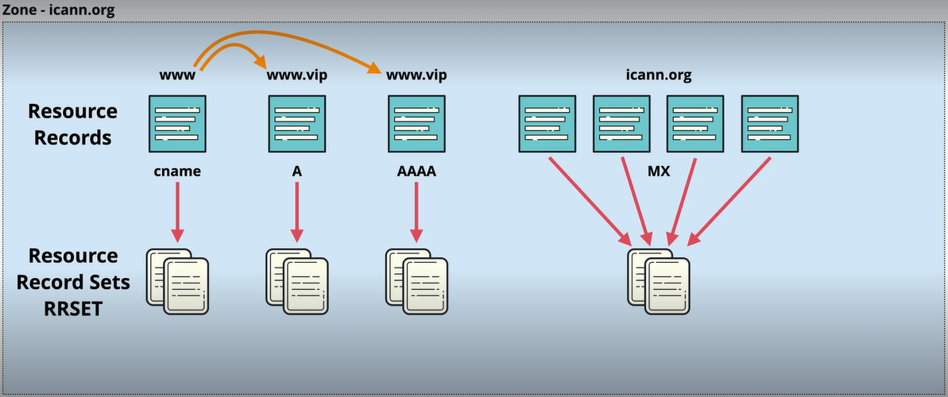
RRSIG stores a digital signature of an RRSET using Public-Private Key, known as Zone Signing Key (ZSK). The Private Key is kept off-line (not stored in the zone).
The process is as follows: Take the RRSET (plain text) and run it through an external signing process. The signature (outcome of the previous process) can be stored as plain text in the zone, using the same name, but its record type will be RRSIG.
The previous process uses digital signing and hashing. If the RRSET changes, the RRSIG must be regenerated. Any unauthorized changes result in an invalid signature.
For a Resolver or a DNS client to verify the RRSIG, we need the public part of the Zone Signing Key (ZSK). This can be found inside a DNSSEC-enabled zone in a record, and it is called DNSKEY Record (stores public keys).
The DNSKey Record can store several different values, such as ZSK or KSK. A flag is used to indicate the type of record, where a 256 flag indicates ZSK, and 257 indicates KSK.
KSK (Key Signing Key) is used to sign keys, such as DNSKEY RRSIG record.
As a summary, we can verify the integrity of data within a DNS zone, eliminating cache poisoning.

DS Records
This is how DNSSEC creates a chain of trust. The public keys in the Root Zone are explicitly trusted.

The Signing Ceremony
Controls the keys to the internet, trust anchor of the DNS systems.
Trust within a DNS zone is typically provided via the parent zone of that zone. The parent zone has a DS record, which is a hash of the Public Key Signing Key of the child zone, and that is how trust is created. In the case of the root zone, there is no parent zone, which means there is nothing to provide that trust.
For this, a more rigorous process is required, something which is secure enough that the output can be absolutely trusted by any DNS resolver and client. We refer to this as the Trust Anchor.
The DNS Root KSK (Key Signing Key) set rarely changed, and the trust is hardcoded into all DNSSEC clients. With them you can define what is valid in the DNS root zone. These are locked away, protected and never exposed. They use redundant Hardwared Security Modules (HSM) also redundant across physical locations. These can only be used in tightly controlled ways.
Due to security of the private Root Key Signing Key is not practical to use it constantly, so there is another key pair which controls the security of the DNS Root Zone. This is known as the Root Zone ZSK (Zone Signing Key).
The whole function of this ceremony is to take the Root Zone ZSK, take this into the ceremony, sign it with the private Root Zone KSK under the tightly security conditions and produce as an output the Root Zone RRSIG DNS Key.
This single record is why DNS from this level down is entirely trusted, because the root zone is trusted via this signing process.

Recovery Point Objective (RPO)
RPO is the maximum amount of data that can be lost during a disaster recovery situation before that loss can exceed what the organization can tolerate. It is something that is generally expressed in minutes or hours (12pm-12pm).
For example, an org saying that their RPO is 6 hours, it means that the organization cannot tolerate more than 6 hours of data loss when recovering from a disaster.
To fight this, we do a backup generally every RPO (every 6 hours in the previous example). Successful backups are known as Recovery Points. If full and incremental backups are used, it’s possible that to restore a single incremental backup, you’ll need the most recent full backup and every incremental backup between that full and the most recent okay incremental backup.
Make sure backups occur as or more often than the desired RPO, a failed backup can double data loss. Lower RPO = more frequent backups = higher cost.

Recovery Time Objective (RTO)
Maximum tolerable length of time that a system can be down after a failure or disaster occurs. Recovery Time begins at the moment of the failure and it ends when the system is operational and handed back to the business. Business and user testing are a requirement for a system to be considered operational.

AWS Fundamentals

Public VS Private Services
The difference between these two just differs in the networking perspective. Public Services are those accessed using public endpoints such as the simple storage service known as S3, which can be accessed from anywhere with an internet connection. A private AWS service is something which runs within a VPC, so only things within that VPC or connected to that VPC can access that service.
A Virtual Private Cloud (VPC) is an AWS Private Zone (such as a home network). These are isolated, so they can’t communicate with each other unless you allow it, and nothing from the internet can access them unless you configure it. Services can be placed into these private zones.
AWS also has a Public Zone that runs between the private zones and the public internet. These zones work as a middle man for private zones and the public internet through gateways, allowing private zone resources to access the public internet, it also allows access to public AWS services such as S3, but the data doesn’t touch the public internet at any point.

AWS Global Infrastructure
AWS is a collection of small groupings of infrastructure connected by a global high-speed network. There are several concepts that will be reviewed in this lesson: AWS region, AWS edge location and AWS availability zone. We will also look at resilience.

AWS Region
Creation of AWS to delimit an area of the world that they have selected (independent of countries or continents), and inside this region there is a full deployment of AWS infrastructure. This means compute services, storage, DB products, AI, analytics and much more.
Some countries have one region, larger nations may have more than one. Regions are geographically spread, and this means that as architects we can use these regions to design systems which can withstand global level disasters.
When interacting with any AWS services, you are actually interacting with that service in a specific region. Regions have three main benefits:
- Regions are separate geographically – Isolated Fault Domain. Something bad happens (terrorist attack, natural disaster) it won’t affect other regions.
- Geopolitical Separation – Different governance. By picking the region, you will be affected by the laws in that region.
- Location Control – Performance. You can place infrastructure as close to your customers as possible.
When referring to a region we can do it two ways; with the region code (aka region) or the region name. in Australia for example, the region is ap-southeast-2, and the region name is Asia Pacific (Sydney). Console UI generally uses region name while interacting with APIs or CLI use region code. If I have infrastructure in the Sidney region and a mirror in the North-Virginia region, if one fails the other won’t be impacted.

AZ
Sometimes a failure is very localized, and AWS provides with a lower-level architectural component: Availability Zone (AZ). Every region provides with multiple AZs (2-6).
These provide isolated infrastructure inside a region, they are isolated compute, storage, networking, power and facilities within a region. If a power outage happens in one of the AZ within a region, the other AZ would still be available.

AWS Edge Location
Often AWS can’t have a region in the same city as all their customers. For this reason, AWS provides Edge Locations. These are much smaller than regions and they often only have content distribution services as well as some type of edge computing, but they are located in many more places than regions. These are useful for example for companies like netflix, that need to store movies as close to their customers as possible. Generally, the further the customers are the lower the data transfer speed and the latency is higher.
AWS have a website ( https://infrastructure.aws ) to visualize how everything is connected.

How to define the resilience of an AWS Service
The resilience level of a service is described at a high level in one of three ways:
- Globally resilient services, relatively few of these within AWS. This means that the service operates globally with a single database, it is one product, and its data is replicated within multiple regions. This means a region can fail and the services continue to work, and it would take the world to fail for these types of services to go out. IAM and Route53 are examples.
- Region resilient services. They operate in a single region with one set of data per region. If you create a database in Sidney and in North-Virginia, they will operate as separate services in each region. They generally replicate data to multiple AZ in that region. The service will only fail if the region fails.
- AZ resilient services. They run from a single AZ, and if this fails the service will fail.

Virtual Private Clouds (VPC) Basics
Service used to create private networks inside AWS that other private services will run from. They are also the service which is used to connect AWS private networks to your on-premises networks when creating hybrid environments, or to connect to other cloud platforms in multi-cloud deployment.
- A VPC is a Virtual Network inside AWS.
- They are within 1 account and 1 region, operating from multiple AZs. They’re regionally resilient.
- Private and Isolated by default. Services deployed into the same VPC can communicate, but it is isolated from other VPCs (unless configured otherwise).
- There are two types: Default and Custom. You can only have one Default VPC per region [EXAM-QUESTION].

VPC Architecture and Default VPC
VPCs are created within an AWS account, within a region (us-east-1 as example). A region can have multiple custom VPCs created within it, unless you configure it otherwise. They can’t communicate outside their specific private network (unless configured), there is a boundary on the edge or perimeter, and no traffic can cross that boundary.
VPCs are regionally resilient. Every VPC is allocated a range of IP addresses, called VPC CIDR, which defines the start and end range of IP addresses that the VPC can use. If anything needs to communicate with the VPC, it must be to the VPC CIDR, and they will originate from the VPC CIDR.
The Default VPC, unlike custom VPCs, only can have one VPC CIDR which is always the same; 172.31.0.0/16.
The way a VPC provides resilience is that it can be divided into subnets (sub networks). Each subnet is located inside a different Availability Zone, and this is set on creation and can never be changed. The default is configured to have one subnet in each AZ.
Each of these subnets use part of the VPC’s range of IP addresses, and these cannot be the same as other subnets in the VPC and they can’t overlap with any of the subnets.

Default VPC Facts
- There can only be one per region – can be removed & recreated (meaning a region may have 0).
- Some services in AWS assume that the Default VPC will be present, so it is always good to have it active but not use it for anything production related.
- Default VPC CIDR is always 172.31.0.0/16
- Inside every default VPC a smaller /20 subnet is created in every AZ in the region (it varies based on the number of AZs in that region).
- Internet Gateway (IGW) allows the VPC to communicate with the internet and viceversa
- Default Security Group (SG) & NACL (Network ACL) are security features that limit incoming and outgoing data transfer.
- By default, anything placed in the VPC subnets is assigned a public IPv4 address.
To create DEFAULT VPC in AWS, go under Actions -> Create default VPC. The Create VPC is used to create custom VPCs.

Elastic Compute Cloud (EC2) Basics
It provides access to Virtual machines, known as instances.
- IAAS – Infrastructure as a Service, provides Virtual Machines => Instances
- Instance – Operating System configured in a certain way, with a certain set of allocated resources.
- Private service by-default – uses VPC networking.
- AZ Resilient – Instance fails if AZ fails, because an instance is launched in a specific subnet, and this is in a specific AZ.
- Different instance sizes and capabilities.
- On-demand billing – Per second or hour. You only pay by what you consume.
- Local on-host storage or Elastic Block Store (EBS).
EC2 instances have an attribute called state, and it can be in one of a few states:
- Running
- Stopped
- Terminated
Running and Stopped are opposite, and they’re used when you have no short term need of an instance, like switching on/off an appliance. If an instance is terminated the instance is fully deleted, and it is non-reversible.
These states matter so much because they influence the charges for the instance.
When an instance is in Running state, it consumes CPU, memory, storage, and network. When the instance is in Stopped state, the instance only consumes storage. This is because the instance is not consuming CPU, Memory or Network since it is not working, but it has storage allocated that cannot be used by other instances, unlike the previous, so you are getting charged by that storage even when the instance is Stopped. The only way to not get charged for anything is to Terminate the instance and get rid of the allocated disk space. Termination is not reversible.

Amazon Machine Image (AMI)
Image of an EC2 instance. It can be used to create an EC2 or it can be created from an EC2 instance. It is similar to a server image used to create Virtual Machines, or a USB with an ISO to install an OS.
- Attached permissions: Every AMI has these, and they control who can and cannot use the image. It can be set as:
  - Public – everyone is allowed to launch instances from that AMI.
  - Owner – Implicit allow (they own it, so they can control it fully)
  - Explicit – Owner explicitly grants access to that AMI for specific AWS accounts.
- Root Volume: Drive that boots the Operating System. It will always have AT LEAST this.
- Block Device Mapping: Links the volumes the AMI has, and how they’re presented to the OS; it determines which Volume (partition) is a Boot Volume (Root Volume) or Data Volume. The OS expects to receive volumes as well as devices ID. The Block Device maps the Volume to an ID.

Connecting to EC2 instances
Instances can run different versions of Linux or Windows. To connect to Windows we use the RDP (Remote Desktop Protocol), which runs in port 3389. With Linux instances we use the SSH protocol, which runs on port 22, and log into that instance using an SSH Key Pair.

Launching EC2 instances
Xux

S3 Basics
Simple Storage Service, it is a Global Storage Platform (runs from all AWS regions) and can be accessed from anywhere with an internet connection (Public Service). It is Regional Based because the information is stored in a specific region.
Data is replicated accross AZ, so it is regional resilient. It is perfect for hosting large amounts of data; it can be used for BILLIONS of IoT devices, or to store pictures for a blog.
It is a very economical service for storing and allowing access to data. S3 is the default storage service on AWS. It delivers two main things:
- Objects: Data that S3 stores (picture, movie, dataset, etc).
- Buckets: Containers for Objects.

Objects
You can think of objects as files. They’re usually interchangeable, and they’re made of two main components and some associated metadata:
- Key: Identifies the object in a bucket.
- Value: Contents of the object, it can vary from 0kb to 5TB.
- Others: Version ID, Metadata, Access Control, Subresources.

Buckets
They are created in a specific AWS region. This has two main impacts:
- Data inside the bucket has a primarely main region, and it never leaves the region unless you configure it. S3 has stable and controlled data sovereignty; by creating a bucket in a region you control what rules and laws affect it. Another factor is that the blast radius is that region (major failure occurs, the region is only affected).
- Bucket Name: It identifies the bucket, and it needs to be globally unique (A name can not be used by anybody else in any AWS account [EXAM-QUESTION]).
A bucket can host an unlimited number of objects, which means a bucket can hold infinite amounts of data.
A bucket has no structure (unlike a file system, folder within folder) so all objects stored are at the same level at the root level. BUT, if you do a listing on a bucket, you will see what seems to be folders (the UI presents it as folders) but that is not how it is. Folders are often referred as prefixes, because they’re part of the object’s name.
Inside S3 there is no file type, everything is objects.

Exam tips
- Bucket names are globally unique.
- Bucket names start with a lowercase letter or a number, and they are 3 – 63 characters, all lower case and no underscores.
- Can’t be IP formatted (1.1.1.1).
- Buckets are LIMITED – 100 soft limit, 1000 hard PER ACCOUNT.
  - An exam question may be ‘How to structure a system with thousands of users (due to the limitation of buckets)’. A valid answer would be to use ONE BUCKET and divide it up using prefixes, so the ‘folders’ (prefixes, there are no folders) divide the users.
- Unlimited objects in bucket, 0 bytes to 5TB per object.
- Buckets have a Key, which is a name and a Value which is the data.

Good and bad applications of S3
- S3 is an object storage system – NOT file or block.
- You can’t mount an S3 bucket as (k:\ or /images)
- Great for large scale data storage, distribution or upload.
- Great for ‘offload’ (blog with lots of posts, you can move it to an S3 bucket, and configure the blog to redirect users to S3).
- INPUT and/or OUTPUT to MANY AWS products. Most services which consume data and or output data can have S3 as an option to take data from or put data to when it’s finished. (EXAM-QUESTION, where to store data? S3 is the default).

[DEMO] Creating an S3 Bucket
Create an S3 bucket used for a campaign within the Animals4Life campaign.
When creating a bucket, the AWS Region is Global. When the bucket is created within S3, a region must be picked (the region that the bucket is within), however S3 uses a global namespace, you don’t have to select a region when using the console, so in the list of buckets all buckets from all regions (created by the user) will show up.
The name of the bucket must be unique globally an a region must be selected. If there are any buckets within the account the user wants to copy, it can be done by choosing the bucket from ‘Choose bucket’ button.
All S3 buckets by default are private. This can be changed from ‘Block Public Access settings for this bucket’. Even if everything gets unchecked, I would still need to grant access to public users. Disabling doesn’t mean the bucket is public, it means you can grant public access.
All resources in AWS have a unique identifier; the ARN (Amazon Resource Name) and they have the following format:
ARN:Partition(most of them will be aws):Service Name:other:values:name
arn:aws:s3:::bucket1
To add files, go to the bucket -> Upload -> Add Files.
To delete a bucket, first we need to empty the bucket by selecting it and pressing the button, then go back to S3 Bucket List page and then delete it.

CloudFormation Basics
Tool which let’s you create, update and delete infrastructure in AWS in a consistent and repeatable way using templates.
They are either written in YAML or JSON. They both do the same, and conversion in between them is easy.
In the Resources section all templates have at least a list of Resources. This section is what tells CloudFormation what to do. If resources are added to it, resources are created, same for update or removal. It is the only mandatory part. Without resources, a template would do nothing.
Resources inside a CloudFormation template are called logical resources. These have a type which is used by CloudFormation to know what to create, and properties which are used to configure the resources in a certain way.
Description is a free text field which let’s the author of the template add a description (what it does, resources changed, cost...). if there is both a description and an AWSTemplateFormatVersion, the description needs to immediately follow the TemplateFormatVersion (right below).[EXAM-QUESTION]
The AWSTemplateFormatVersion is the way AWS allow for extending the standards over time. If admitted this value is assumed.
The metadata can control how the different things in the CloudFormation template are presented thorough the console UI. Generally, the bigger the template the more likely it’ll have this section.
The parameters are where you can add fields which prompt the user for more information.
Mappings is something we won’t use as much, but it allows you to create lookup tables.
Conditions allow decision making in the template, that will only occur if a condition is met. There are two stages, creating the condition and using the condition in the resources part of the template.
Outputs are a way that once the template is finished it can present outputs based on the outcome.
When you give CloudFormation a template it creates what is known as a Stack, which contains all of the logical resources that the template tells it to contain. It is an active and living representation of a template.
For every Logical Resource in the Stack, CloudFormation makes a corresponding Physical Resource in your AWS account.
When you delete a Stack, the logical resources are deleted which causes the physical resources being deleted.

CloudFormation Demo
CFN has several templates created. We can create one from their pool or upload our own.
Whenever a template is uploaded to CFN, what is actually happening is that the template is uploaded to an automatically created S3 Bucket.

CloudWatch Basics
It is a support service which is used by almost all other AWS services (management and monitoring specially).
It collects and manages operational data. This is any data generated by an environment either detailing how it performs, how it nominally runs or any logging data it generates. It performs three main jobs:
- CloudWatch: Product which allows collection of metrics, monitoring of metrics and actions based on metrics. Metrics is data relating to AWS products, applications or on-premises systems. CPU utilization of a EC2 instance would be an example. It is a Public Service. Some metrics are gathered natively by the product and others need an extra piece of software. CloudWatch Agent is used to collect metrics outside of AWS, in other cloud environments or in on-permise environments.
- CloudWatch logs: Collection, monitoring and actions based on logging data. Windows event logs, server logs, firewall logs... For anything outside AWS natively, on-permises etc, you’ll need to install CloudWatch Agent.
- CloudWatch Events: Functions as an event hub. It provides two powerful features:
- If an AWS service does something (EC2 instance terminates for example), CloudWatch events will generate an event which performs another action.
- Generate an event to do something at a certain time of week or certain days of week.

Namespace
Container for monitoring data. Its a way to keep things from becoming messy and separate them into different areas.
All AWS data goes into an AWS namespace which is called AWS/serviceName (AWS/EC2). This styling for the name is reserved for AWS.
Namespaces contain related metrics.

Metric
Collection of related data points in a time ordered structure. For example, CPU utilization, network In/Out or Disk I/O.
Metrics however are not for a specific server. CPU utilization is the metric, and that metric may be receiving data from lots of different EC2 instances. So we need something else to identify which things log data to a specific metric.

Datapoint
Every time a server measures and reports its utilization into CloudWatch, that measurement is called datapoint. Datapoints consists of two things:
- Timestamp, which includes Year, Month, Day, Hour, Min, Second and Time- zone when the measure was conducted.
- Value, indicating the measure.
To separate and identify where the data is coming from, we use dimensions.

Dimension
Let’s say we have three EC2 instances. Each of them sends datapoints into the AWS EC2 namespace and the CPU utilization metric, one per second.
The metric is now receiving 3 datapoints per second. What is also sent with those datapoints are dimensions, which are name value pair which allow CloudWatch to separate things or provide different perspectives of things within a metric.
For example, an Instance will have InstanceID and Value, now we can look into AWS/EC2 namespace for a particular InstanceID.

Alarm
Created and linked to a specific metric, then based on how it is configured it will take an action based on that metric.
An alarm being in an OK state means everything is good. If it is moved into an ALARM state, means something bad happened. Based on the previous, you can define an action.
Alarms have a third state, which is INSUFICIENT_DATA, and this is usually the initial state when the Alarm doesn’t know yet whether is OK or ALARM.

Shared Responsibility Model
It applies to the wider cloud platform from a security perspective. It’s AWS’ way of making sure that it’s clear which elements you manage and which elements are managed by AWS.
AWS are responsible for the Security of the Cloud. You as a customer are responsible for the Security in the cloud.

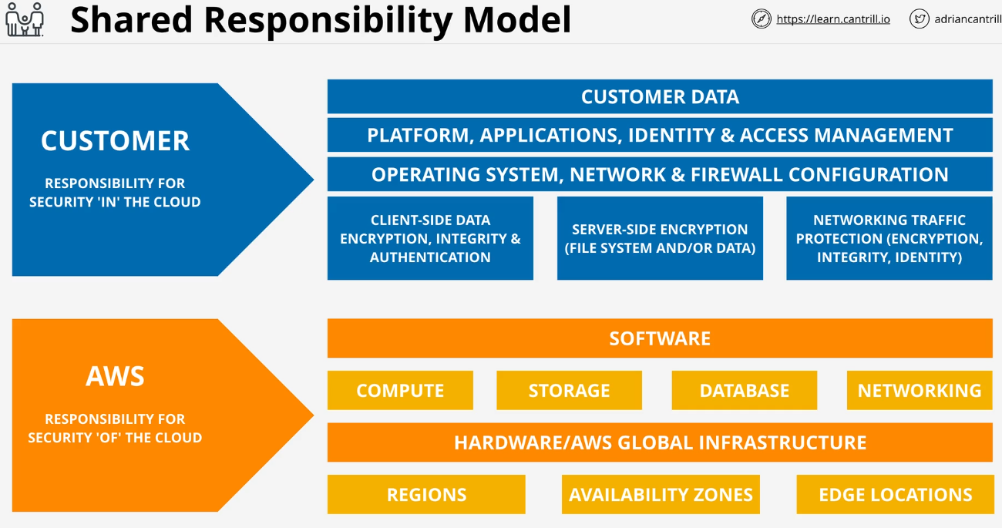
High Availability (HA) vs Fault Tolerance (FT) vs Disaster Recovery (DR)

High Availability
It aims to ensure an agreed level of operational performance, usually uptime (time that a machine is in operation), for a higher than normal period.
Making a system Highly Available DOES NOT mean ensuring the system never fails, or that the users don’t experience any outages.
A highly available system is one designed to be online and providing services as often as possible. When it fails, its components can be replaced or fixed as soon as possible, often using automation to bring systems back into service. IT IS NOT about user experience, it is about maximizing a system’s online time.
High availability is represented by a percentage of uptime. For high availability, user disruption (a user has to log back in) is ok.

Fault Tolerance
Is the property that enables a system to continue operating properly in the event of a failure of some (one or more faults within) of its components.
If a system has faults, then it should continue to operate properly even while those faults are present and being fixed.
It means it has to continue operating through a failure without impacting customers.
First you need to minimize outages, but also need to design a system to tolerate a failure, which means levels of redundancy and system components which can route traffic and sessions around any failed components.
A plane would be a good example.

Disaster Recovery
Set of policies, tools and procedures to enable the recovery or continuation of vital technology infrastructure and systems following a natural or human-induced disaster.
It is about what to plan for and do when disaster occurs, which knocks out a system. What if HA and FT don’t work? Given a disaster, what happens before and after.
It is designed to keep the crucial and non-replaceable parts safe.

Summary
- High-Availability - Minimize any outages
- Fault-Tolerance – Operate Through Faults and failures (much more complex and expensive than HA).
- Disaster-Recovery – Used when the two previous don’t work. One of the things the exam tests is how to recover.

Route53 Fundamentals
It provides two main servers:
- Register Domains
- Host zone files on managed nameservers which it provides.
It is a Global service with a single database (one of the very few) so you don’t need to pick a region when using it.
The data it stores and manages is distributed globally as a single set, and it is replicated between regions so it’s a globally resilient service. It can tolerate the failure of one or more regions and continue to work without problems.
It is one of the most important AWS products, so it needs to stay Highly-performant whilst remaining reliable, and continue working through failure.
When a domain is registered, a few things happen:
- First Route 53 checks with the registry for that top level domain (.com, .org...) if the domain is available.
- Route53 creates a zone file for the domain being registered (Database which contains all of the DNS information for a particular domain).
- It also allocates name service for this zone, which are servers which Route53 creates and manages which are distributed globally, and there are generally four of these for an individual zone. It takes the zone file that is being created, (this is known as a Hosted Zone) and it puts that zone file onto the four managed name servers.
- It communicates with the registry and liaising with the registry, it adds the name server records into the zone file for the registry top level domain, using Name Server Records.
By adding the Name Server Records, it is indicating that our four name servers are authoritative for the domain.
As a summary:
=> Creation of a Zone File.
=> Creation of a number of managed name servers.
=> Put the zone file on the servers.
=> Liaising with the registry for the top level domain and getting name server records added to the top level domain zone, which point back at these servers.

Route53 zones
Route53 provides DNS zones as well as hosting for those zones. It is basically DNS as a service.
It lets you create and manage zone files, which are called Hosted Zones because they’re hosted on AWS four managed name servers.
A hosted zone can be public, which means the data is accessible in the internet, or private which means it is linked to one or more VPC and only accessible from one or more VPCs, and this can be used for sensitive DNS records that you don’t want to be publicly accessible.
A hosted zone hosts DNS records. Inside Route53 records are referred to as record sets.

DNS Record Types

NameServer (NS)
Record Types which allow delegation to occur in DNS. Let’s take ‘.com’ as an example:
- This zone is managed by Verisign. This zone will have multiple nameserver records inside it for, for example ‘amazon.com’. These records point at servers managed by the ‘amazon.com’ team, and these servers host the ‘amazon.com’ zone.
Inside this zone are DNS records, such as ‘www.’ which is how you can access those records inside DNS.

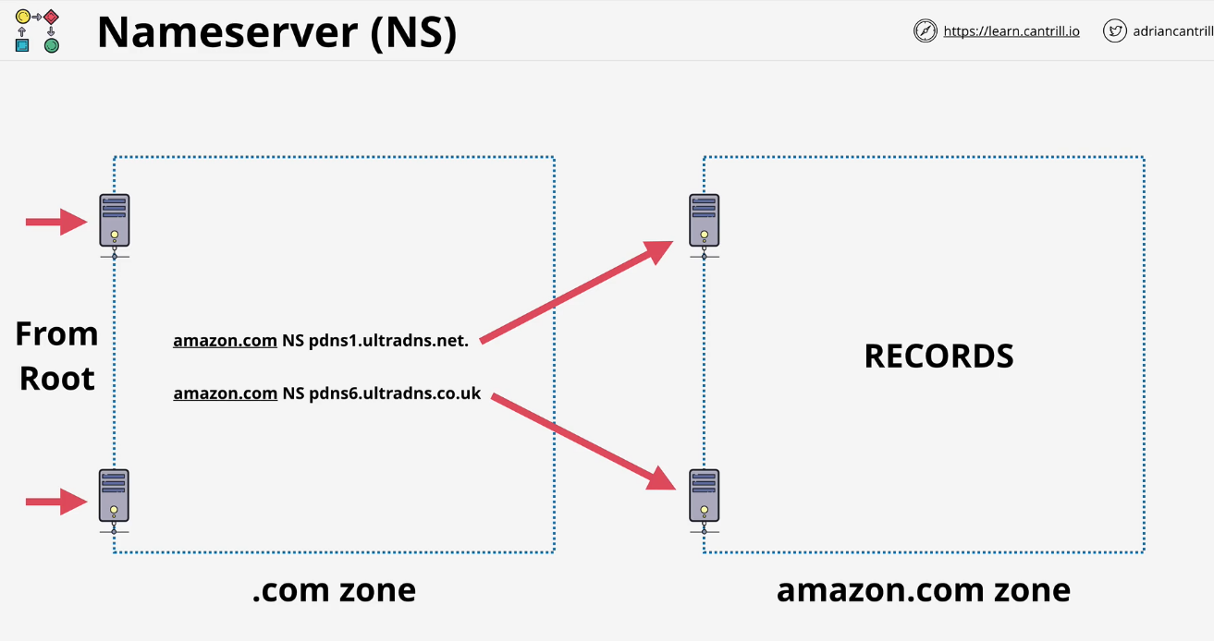

A and AAAA Records
Given a DNS Zone, this type of records map host names to IP addresses, the difference is the type of address.
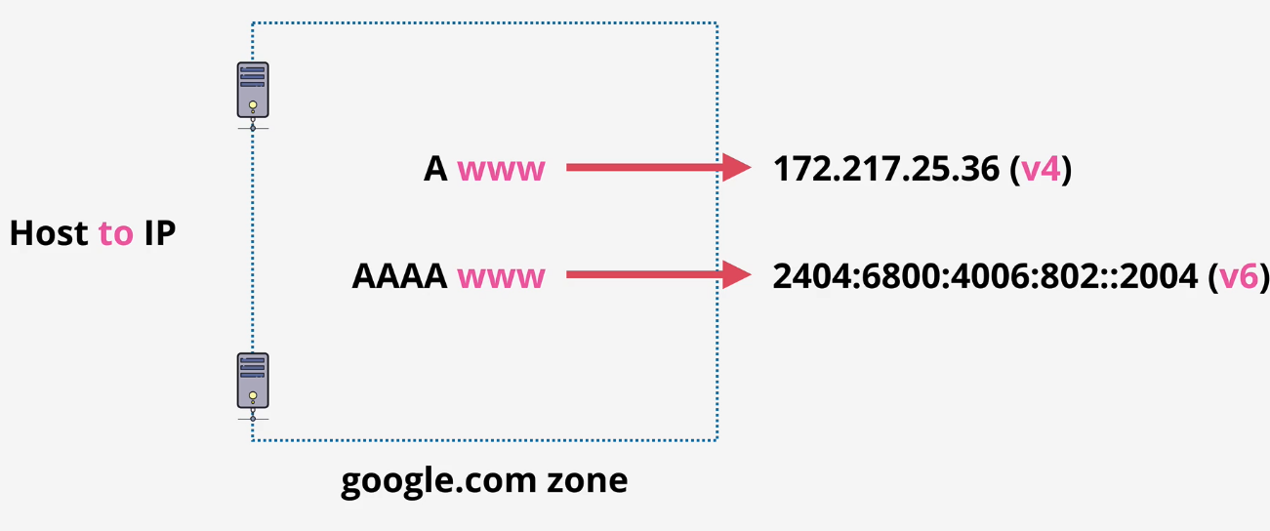
Generally as a solutions architect, you will create two records with the same name. One will be an A record and the other will be an AAAA record. The client OS and DNS software can then pick the correct type of address it wants.

CNAME Record
For a given zone the Canonical Name (CNAME) lets you create the equivalent of DNS shortcuts (host to host records).
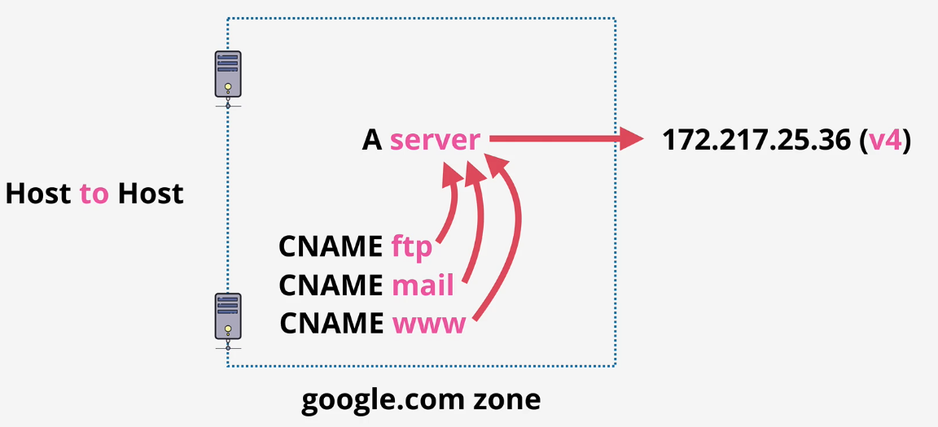
A record called server points at an IPv4 address. It’s fairly common that a given server performs multiple tasks, such as FTP, Mail and WebServices. Creating 3 CNAME and pointing them all to the A server record, means they will all resolve to the same IPv4 address.
CNAMEs are used to reduce admin overhead. In this case if the IP address changes, it is just the single record to update, the A record.

[EXAM-QUESTION] CNAMEs cannot point directly at an IP address, only other names (trick question)

MX Record
Hugely important for how the internet works, specifically email. Let’s say you’re sending an email. MX Records are used as part of this process so the email server can know which server to pass the email onto.
MX records have two parts; a priority and a value. The value can be just a host (no dot on the right) and it is assumed to be part of the same zone that it’s in. If you include a dot on the right, it means it is a Fully Qualified Domain Name and it can either point to the host inside the same zone, or something outside that zone. After the query, whichever has the highest priority is called and used if available, if not the others will be used in function of their priorities.
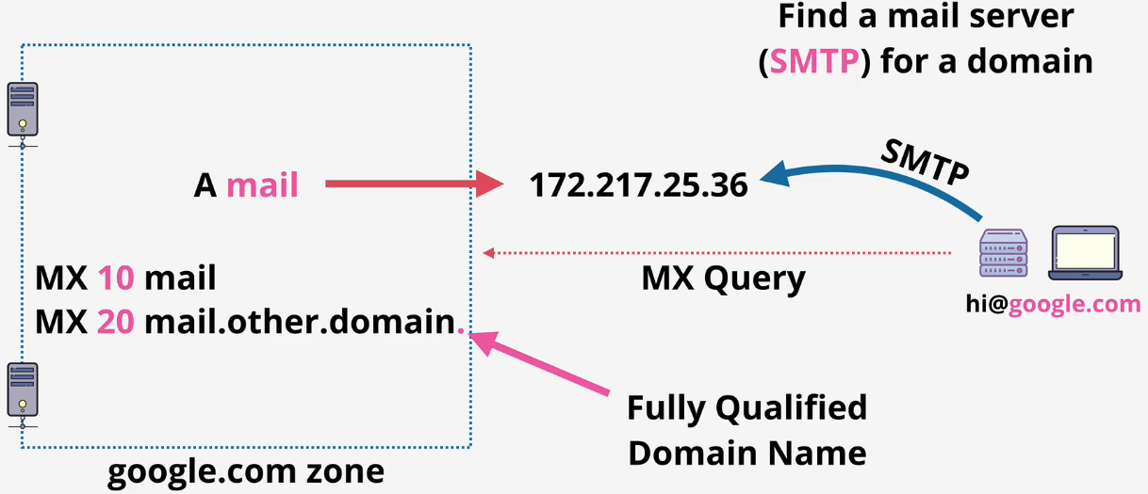
In summary, an MX record is how a server can find the email server for a specific domain. Whenever you send an email to a domain, the server sending the email on your behalf is using DNS to do an MX lookup and locate the mail server to use.

TXT Records
Text records allow you to add arbitrary text to a domain. Its a way in which the DNS system can allow extra functionality. One common usage is to prove domain ownership.

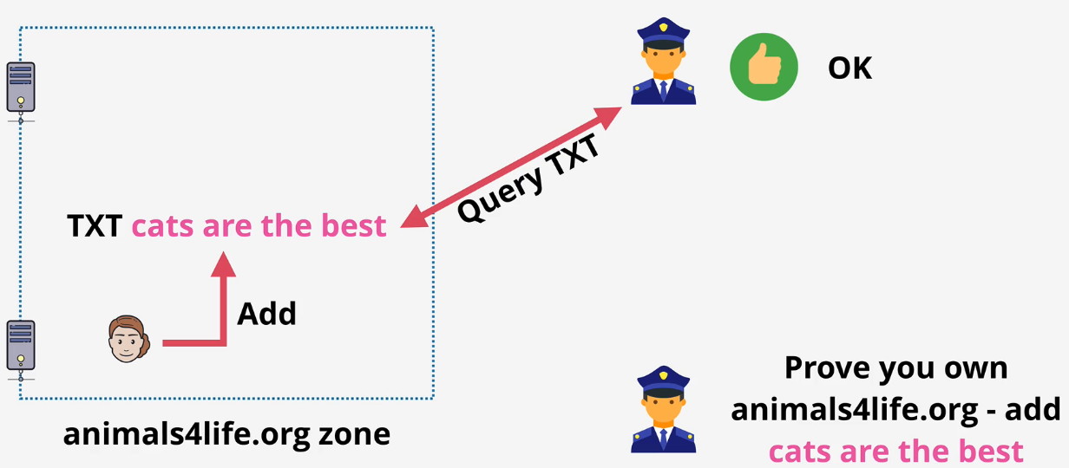
DNS TTL (Time To Live)
A TTL value is something that can be set on DNS records. Its a numeric value in seconds.
You get an authoritative answer by talking to a DNS server which is authoritative for that particular domain. So if I am quering the nameserver for amazon.com and I am querying the www record in amazon.com I get back an authoritative answer.
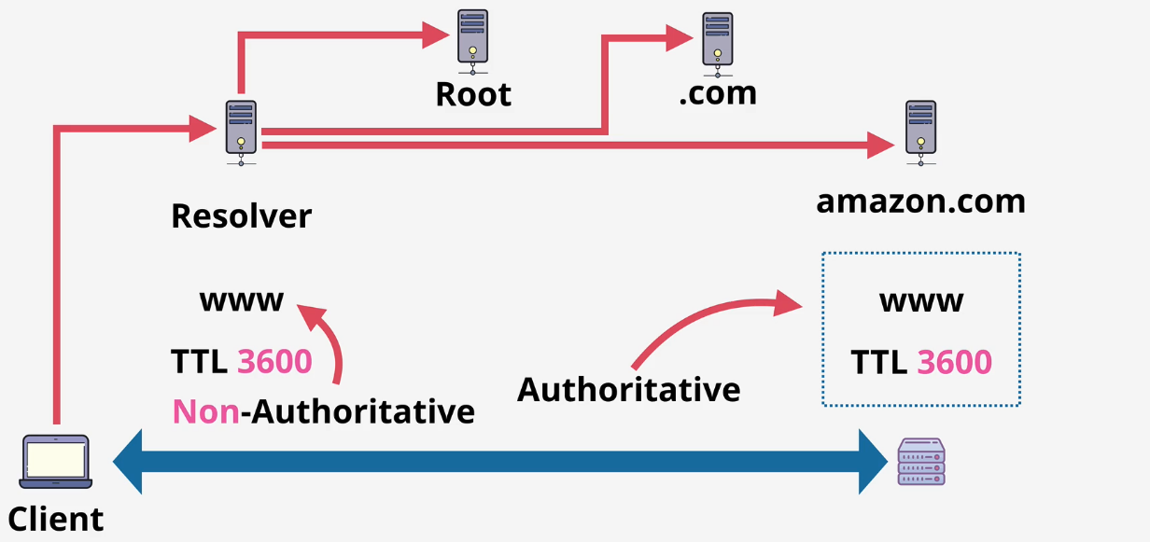
Using TTL the admin can indicate how long records can be cached for.
If another client queries the same thing, then they will get back a non-authoritative answer, but that answer will be retrieved immediately, because that answer is in stored (for as long as indicated on the TTL) in the resolver server (hosted at our internet provider), so it’s much quicker to access that data. Non-Authoritative answers are usually the same as Authoritative, normally things on DNS don’t change.
TTL is important for when things change. If you migrate your email server and you have a high TTL value on your MX record, and change to a provider with a different IP address, email delivery may be delayed because old IP addresses for those MX records will be cached and used.
TTL is a balance:
- Low values -> more queries against your nameservers.
- High values -> less queries but also less control if you need to change records.
The resolver should, but not always obeys TTL values. DNS is often the cause of project failures because of TTL values. If any work involving changing DNS records is being done, it is recommended to lower the TTL value well in advance of the work (days or weeks); this will ensure there are less caching issues when you finally do change those records.

Review Questions
- What Permissios options does an AMI have?
  - Public Access, Owner Only, Specific AWS Accounts.
  - Public Access, Owner Only, Specific IAM users.
  - Public Access, Owner only, Specific Regions.
  - Public Access, Specific AWS Accounts, Specific IAM Users.
- What is NOT stored in an AMI?
  - Boot volume.
  - Data volumes.
  - AMI Permissions.
  - Block Device Mapping.
  - Instance Settings.
  - Network Settings.
- EC2 is an example of which service model?
  - PAAS
  - IAAS
  - SAAS
  - DBaaS
  - FaaS
- What is true of an AWS Public Service?
  - Located in the public internet zone
  - Located in the AWS Public Zone
  - Located in a VPC
  - Publicly accessible by anyone.
  - Anyone can connect, but permissions are required to access the service.
- What is true of an AWS Private Service
  - Located on the Public Internet
  - Located in the AWS Public Zone
  - Located in a VPC
  - Accessible from the VPC it is located in.
  - Accessible from any other VPC.
  - Accessible from other VPCs or on-permises networks as long as private networking is configured.
- What is true of Simple Storage Service (S3)
  - S3 is an AWS Public Service.
  - S3 is a private service
  - S3 is a web scale block storage system
  - S3 is an object storage system
  - Buckets can store a limit of 100TB of data
  - Buckets can store an unlimited amount of data
- What is a CloudFormation Logical Resource
  - A resource in a stack which hasn’t been created yet
  - A resource defined in a CloudFormation Template
  - A resource created in an AWS Account by CloudFormation
  - A name given to a resource created with best practice configuration
- What is a CloudFormation Physical Resource
  - A resource defined in a CloudFormation template (EC2 Instance).
  - A physical resource created by creating CloudFormation stack.
  - A product in AWS which is a physical piece of hardware (router).
  - None of the above.
- What is a simple and correct definition of High Availability
  - A system which maximizes uptime.
  - A System which is highly performing.
  - A system which can operate through failure.
  - A system which has regular backups and restore processes.
- Which of the following is a correct definition of a Fault-Tolerant system
  - A system which uses automation to return a service to operational status with little user disruption
  - A system which has a 99.999% uptime
  - A system which allows failure, and can continue operating without disruption.
  - A system which has a regular and reliable system backups and restore processes.
- How many DNS root servers exist?
  - 12
  - 13
  - 7
  - 100
- Who manages the DNS Root Servers
  - IANA
  - 12 Large Organizations
  - IANA Root Server board
  - Google
- Who manages the DNS Root Zone
  - IANA
  - 12 Large Organizations
  - IANA Root Server Board
  - Microsoft
  - Nobody manages the root zone – it’s managed via the root hints file
- Which DNS Record Type converts a HOST into an IPv4 Address
  - A
  - AAAA
  - TXT
  - MX
  - CNAME
  - NS
- Which DNS Record type is how the root zone delegates control of .org to the .org registry
  - A
  - AAAA
  - TXT
  - MX
  - CNAME
  - NS
- Which type of organization maintains the zones for a TLD (i,e. .org)
  - Registrar
  - Registry
  - IANA
  - None of the above.
- Which type of organization has relationships with the .org TLD zone manager allowing domain registration?
  - Registrar
  - Registry
  - IANA
  - None of the above
- How many subnets are in a default VPC
  - 2
  - 3
  - Equal to the number of AZs in the region the VPC is located in
  - 10
- What is the IP CIDR of a default VPC
  - It depends on the regional
  - Random based on the AWS account
  - You can configure an IP range suitable for your network
  - 172.31.0.0/16
  - 10.0.0.0/16

IAM, Accounts and AWS Organizations

IAM Identity Policies
Type of policy which get attached to identities inside AWS. There are three type of identities: IAM users, IAM groups and IAM roles.
An IAM identity policy (aka policy documents) is just a set of security statements to AWS. It grants or denies access to AWS products and features, to any identity which uses that policy. These documents are created with JSON.
When an identity tries to access AWS resources, that identity must prove to AWS who they are (authentication). Once authenticated, that identity is known as an authenticated identity. AWS has a collection of policies that apply to an identity (they can be multiple).
A statement only applies if the interaction you’re having with AWS match the action or the resource. Parts of a statement:
- Sid: Optional field, let’s you identify a statement and what it does.
- Action: Action being performed.
- Effect: Either “Allow” or “Deny”. Controls what AWS does if the action and the resource part of the statement match the operation that you’re attempting to do with AWS.
- Resource: Matches AWS resources. Individual or lists, wild cards for every resource, for list of resources use ARN format.
Policies may overlap each other.
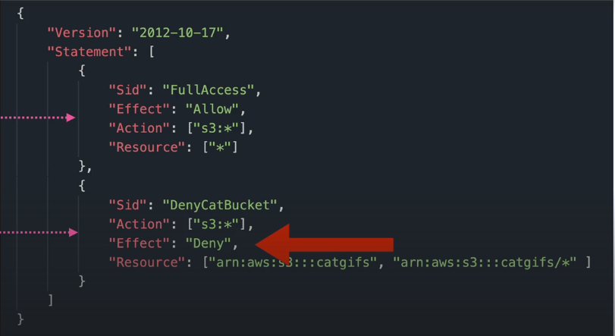

In this example, the first statement grants full access to all S3 actions on all resources. At the same time, in the second statement access to any object in the catgifs buckets is denied.
This may sound confusing but it actually follows a rule:
- We start by the first priority are explicit denies. What it means is if you have a statement which explicitly denies access to something it will overrule everything else.
- Second, explicit allows. These take effect unless there is also a explicit deny.
- Lastly, if you attempt to do something for what you have no explicit allow or deny, then the default implicit deny takes effect. If they are not allowed access, they have no access.
If a user is part of different groups on top of their own policies, AWS gathers the policies together and looks at them at the same time, with the same Deny-Allow-Deny hierarchy.

Inline policies
Policy that grants access to the resources needed for a particular project, and then apply the JSON file to each individual account, which becomes three isolated bits of JSON. NOT BEST PRACTICE. They are generally used for exceptions or special circumstances.

Managed Policies
Created as their own object, create managed policy (JSON file) and then attach that policy to any identities who you wanted to gain those access rights. They are better because:
- They are reusable
- Low Management Overhead

IAM Users
Identity used for anything requiring long-term AWS access, like humans, applications or service accounts.
If you need to give an application access to your AWS account, for example a backup application running on people’s laptops, then each laptop generally would use an IAM User.
If you can picture one thing, a named thing, then 99% of the time will need an IAM User.
IAM starts with a principal, which represents an entity trying to access an AWS account. Principals can be individual people, computers, services or a group of all of those things.
For a principal to be able to do anything it needs to authenticated and be authorized. The principal needs to authenticate against an identity within IAM. An IAM User is an identity that can be used in this way.
- Authentication: The IAM user proves to be who they say they are, using Username and Password or Access Keys.
- Authorization: AWS checks the statements that apply to the identity and either allow or deny access.

Amazon Resource Names (ARNs)
They uniquely identify resources within any AWS account. They allow you to refer to one resource or several using wildcards.

EXAM POWER-UP

- 5,000 IAM Users per accounts
- IAM User can be a member of 10 groups.
This has systems design impacts. If you have a system that requires more than 5,000 users, then you can’t use one IAM user for each identity. This may be a limit for internet-scale applications, or large organizations or mergings.
If you have an application with more than 5,000 identifiable users (identities), then its likely IAM Users won’t be the right solution. There are other solutions that fix this, like IAM roles or Identity Federation.

IAM Groups
IAM Groups are containers for users. They exist to make organizing large sets of IAM Users easier. You can’t login in to IAM groups and IAM groups have no credentials of its own.
Groups can have both inline and managed policies. There is no nesting of groups.
There is a limit of 300 Groups per account, but this can be increased with a support ticket.
Groups are not a true identity. They can’t be referenced as a principal in a policy. A resource policy cannot grant access to an IAM Group (you cannot refer to them in policies).

IAM Roles
A role is one type of identity which exists inside an AWS account (the other type are IAM Users). The main difference is that roles are generally best suited to be used by an unknown number of principals. This might be multiple AWS Users inside the same account, or it could be humans, applications or services inside or outside your AWS Account.
Roles are used in a temporary basis. Something becomes that role for a short period of time and then stops. The role doesn’t represent you, it represents a level of access within an AWS account. With a User, you log and it represents you. IAM roles have two types of policies:

Trust Policy & Permissions Policy
A trust policy controls which identities can assume a role. It can reference identities in the same account (other users, other roles and even services such as EC2), and also identities in other AWS accounts.
Temporary Security Credentials are generated for the roles, and they expire after a certain time. These temporary credentials will allow access to whatever AWS resources are specified within the Permissions Policy.
The operation used to assume the role and get the credentials is the STS, Secure Token Service -> sts:AassumeRole.

When to use IAM Roles
- Within your own AWS account a common use is for AWS services themselves. They operate on your behalf and they need access rights to perform certain actions. AWS services have no permissions by default.
For example, we can use AWS Lambda and provide an IAM Role. Let’s call this role Lambda Execution Role. This role has a trust policy which trusts the Lamba service, and this means that Lambda is allowed to assume the role whenever a function is executed.
The role, has a permissions policy which grants access to AWS products and services. When it runs it uses the sts:AssumeRole operation and the Secure Token Service generates temporary security credentials and then the runtime environment that the Lambda function runs in can use these temporary credentials to access AWS resources.
If in this case we didn’t use roles, this would mean we would have to hard-code the permissions into the Lambda function by explicitly providing access keys for that function to use (USE ROLES IF POSSIBLE – hard-coding entitles security risk, future problems when in need to change or rotate the security keys).
- Emergency or out of the usual situations. This is a break-glass case (where a key is behind a glass and you have to break that glass to get the key). We can assume an emergency role when absolutely required, which will grant more aggressive permissions than usual (grant delete access to a user with read-only permissions). These emergency situations are logged, so it will be known that whoever used the emergency role, did it.
- When adding AWS into an existing corporate environment. A corporate that has more than 5,000 workers can’t be offered a single user for each worker, since it is over the limit IAM Users offer. In this case, a role can be used to reuse identities within AWS. External accounts or external identities cannot be used directly to access AWS resources. You can’t use Facebook, Twitter or Google identities to interact with AWS.
How this works is you allow one role within your AWS account to be assumed by one of the external identities. When the role is assumed, temporary credentials are generated and these are used to access the resources.
- Architecture for a popular mobile application. An application with millions of users will need to retrieve and store data from a database product (DynamoDB). It is important to note that:
- When you interact with AWS resources you need to use an AWS identity.
- There is a 5,000 limit per account.
Most mobile applications let you log in using web identities (facebook, google, twitter). We can trust and allow these identities to assume a role.
- Cross-account access. Multi-account environment (mine and a partner). The partner has an S3 bucket where they want me to store any data inside. My account has thousands of identities and the partner doesn’t want to create IAM users for my staff. In this situation the best solution is to use a role in the partner account that my users can assume to get temporary security credentials and store data in the S3 bucket.

Service Linked Roles
IAM role linked to a specific AWS service. They provide a set of permissions that is predefined by a service.
They provide permission that a service needs to interact with other AWS services on your behalf. The Service might create/delete the role, or allow you to during the setup or within IAM.
The key difference between service-linked roles and normal roles is that you can’t delete a service-linked until it is no longer required (no longer used in that AWS service).
Different services have different Resource links (format can differ and it is case sensitive) DO NOT GUESS.
Another difference is role separation. This is where you might give one group of people the ability to create roles and another the ability to use them.

AWS Organizations
Product which allow larger businesses to manage multiple AWS accounts in a cost-effective way with little to no management overhead.
First take a single AWS Account, known as Standard (not within an organization), and create an organization.
The organization IS NOT created in this account; you’re just using the account to create the organization.
The Standard account then becomes the Management Account (or Master Account) for the organization.
When Standard AWS Accounts join an organization, then they change from Standard to Member Accounts of that organization.
Management Account | Member Account
1 AND ONLY 1 account | 0 or more accounts

If there are multiple accounts in an org, you can create a structure of accounts.
The structure is hierarchical, it is an inverted tree. On top, there is the Organization Root, which is just a container for AWS Accounts which exists at the top of the organizational structure.
Within the OR, we can find accounts or other containers called Organizational Units OU, which can contain AWS accounts or other OUs so you can build a nested hierarchy.
Consolidated Billing is when the individual payment methods from other accounts have been removed and the member accounts pass their billing to the Management Account. Management Accounts are sometimes referred to as the Payer Account.
You can create new accounts within organizations. When doing so, there is no invite required to access the organization.
Within Organizations there is no need to have IAM Users for every account, instead IAM Roles can be used to access other AWS accounts.

Creating the AWS account structure
1. Login into the IAM admin user of the general AWS account.
2. Go into AWS Organization – Create an organization.
Once the process is completed, the standard AWS account will become the management account of the organization.
3. An email (NOT ALWAYS, notification will show up) is sent to verify the account as a new organization account.
4. To add an account, with the Account ID (from the account we want to invite) press on ‘Add AWS Account’, Invite existing AWS account and provide the email address or the account ID. To finish, ‘Send Invitation’.
Note: If an error message is received, just log a support request asking for an increase in the number of AWS accounts which can be part of an AWS org.
5. The AWS account I am trying to get to join must accept the invitation, from the AWS Organizations console.
When adding an account into an organization, you can either invite an account into the org or create an account within the org. In the latter, a role is created within that account, which can be role switched by other accounts within the organization. If you invite an existing AWS account into the organization, then the role needs to be created manually.
7. In the production account, go to IAM - Roles – Create Role. For the trusted entity, select Another AWS Account. For the account ID, we need the ID of the General (management account of the org) account. This will mean that the general account is meant to trust this role.
8. This account will have administrator access, so look for AdministratorAccess and click on next. Add a name for the role.
9. This role is going to be used when we’re logged into the general account, and we want to role switch into the production account to perform administrative functions. The name used is a standard name that AWS uses as a default when creating accounts within the org. OrganizationAccountAccessRole.
Under Trust Relationships, we can find the ID of the general account.
10. To switch roles, copy production’s ID, go to general account, (only will work with IAM identities, so make sure I am logged in into the iamadmin), click the account drop-down menu from the Console Home, and select ‘Switch Role’.
11. Press on Switch Role again, and provide with the Account ID and the Role previosly created (OrganizationAccountAccessRole). The DisplayName will create a quick access for future reference in the browser.
12. To finish, press Switch Role again. Now, this is role switching into the Production account, using the assume role API call to assume the role that you just created. Now there is a history role switching, so I can quickly access the prod account or other roles added.
13. As a next step, I am going to create the development AWS account within the organization. So we go to AWS Organizations, add account, but this time create an AWS account.
14. Fill up information. A role is created automatically by AWS because when you create an account within an organization, the only method you have to access this account is by switching role into that account.
15. Now AWS have created the OrganizationAccountAccessRole in our behalf, with the Trust Relationships already created as well.

Service Control Policies
SCPs are a feature of AWS Organizations used to restrict AWS Accounts. They are written as JSON documents, and they can be attached to the organization as a whole by attaching them to the root container, they can be attached to one or more organizational units or even to individual AWS accounts.
They inherit down the organizational tree; if they are attached to the root container they will affect the whole organization, if they are attached to an OU (Organizational Unit), they’ll impact all accounts inside that OU.
However, the management account is never affected by SCPs.
- SCPs are account permissions boundaries.
- They limit what the account (including root user) can do.
- They don’t grant any permissions.
SCPs can be implemented in two different ways: Allow list vs Deny list.

Deny List
The default of an SCP Deny List is a ‘Full Access Policy’, which doesn’t grant permissions for everything but rather doesn’t apply any restrictions. To apply any restrictions, you must indicate what is restricted.

Allow List
The Allow List is the opposite; to implement it, it must be done in two parts:
- First create an SCP removing FullAWSAccess policy. Only the implicit default deny is in place and active.
- Second, you need to add any services you’d want to allow into a new policy.

Using SCP
How to use SCP to restrict what identities within AWS can do, as a feature of Organizations.
A good point to start is by tiding up the Organization structure. To do so, from Organizations:
- Select the Root.
- Actions – Organizational Unit: Create New.
Once the folders are created:
- Select the account.
- Actions – AWS Account: Move.
If we need to activate SCP, go to AWS Organizations, Policies, Service control policies, Enable service control policies. This will add an AWS Full Access policy into the entire organization.
To apply a policy to a whole folder, click on the folder, Policies, Attach.

CloudWatch Logs
Public service (the endpoint where applications connect to is hosted in the AWS public zone). You can use the product on AWS VPCs or from on-premises environments, and even other cloud platforms.
It allows you to store, monitor and access logging data. Logging data is a piece of information data, and a timestamp.
They are also able to capture data and generate a metric based on the logged data. This is called a metric filter. You can later, have alarms trigger based on those metrics.
CloudWatch is a Regional Service (e.g. us-east-1), with a starting point on Logging Sources (AWS products, mobile or server-based applications, databases, APIs...). These sources inject data into CloudWatch as Log Events.
Log events are treated as raw data (time+message), and they are stored into the Log Stream, which is a sequence of log events from the same source. Log streams can be grouped in Log Groups, which are containers for multiple Log Streams for the same type of Logging.
Log Groups are also the place storing configuration settings, such as retention settings and permissions. Once they are defined for a group, they apply to all Log Streams in that group.
Metric filters are also defined in groups. These are constantly reviewing any log events for any log streams in that group, and when detected, they increment a metric, and those metrics can have alarms associated.
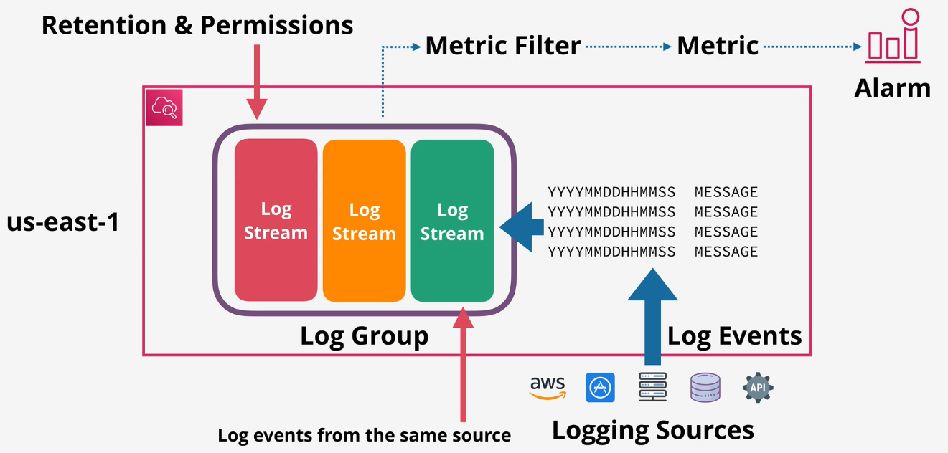

CloudTrail Essentials
Product that logs API actions which affect AWS accounts. e.g., if you stop an instance, if you change a security group, if you create or delete an S3 bucket are examples of what CloudTrail would log.
The product logs API calls or activities. Each logged activity os called a CloudTrail Event. The latter is a record of an activity in an AWS account, either taken by a user, a role or a service. It stores by default the last 90 days of CloudTrail Events in the Event History. This is an area of CloudTrail which is enabled by default, and it has no cost for 90 days of history on an AWS account. If I need to customize the service in any way superior to 90 days, I need to create a trail.
There are three different types of events:
- Management Events: Provides information about management operations performed on resources on your AWS account. AKA Control Plane Operations (example, creating an EC2 instance). Logged by default
- Data Events: Contain information about resource operations performed on or contained in a resource (example, objects being uploaded to S3). Disabled by default, must be specifically activated when creating a trail.
- Insight Events (IF APPLIES WILL TALK LATER ON ABOUT IT)
A CloudTrail trail is the unit of configuration within the CloudTrail product. It is a way you provide configuration to CloudTrail on how to operate. A trail logs events for the AWS region that it’s created in, it is a regional service.
However, when it is created it can be configured to operate in one of two ways:
- Create a one-region trail. Created on one region, only logs events for that region.
- Create a trail set to all regions. Collection of trails in every AWS region, but managed as one logical trail. If AWS adds any new regions, then an all-region trail is automatically updated.
---------------------------------------------------------------------------------------------------------------------

IMPORTANT
AWS services are largely split up into regional services and global services so when these different types of services log to CloudTrail, they either log in the region where the event is generated in (regional services) or they log to US East 1 (global services)
---------------------------------------------------------------------------------------------------------------------
When creating trails, the 90-day default can be changed. For example, a trail by default can store the events in a definable S3 bucket, and the logs generated can be stored there indefinitely. The logs are written in a file in JSON format, occupying barely any space. In addition, another advantage is that any tool able to parse these files will allow you to work with them.
CloudTrail can also be integrated with CloudWatch Logs, and all of the logging data that it generates can be put into CloudWatch Logs and use a metric filter to navigate through the data.
A new feature is that you can now create an organizational trail, and this means if you create this trail from the management account of an org, it can store all of the information for all of the accounts in the organization.

Summary
- CloudTrail is enabled by default, with a 90-day limit. If you want S3 you need a trail.
- Trails are how you configure S3 and CloudWatch Logs.
- Only management events are stored by default, not data.
- Regional services log events in a region. Global Services log events to US-East 1, and a trail needs to be enabled to capture that data.
- CloudTrail is NOT REAL TIME – there is a delay. It typically delivers log files within 15 minutes of the account activity occurring.

Implementing an Organizational Trail
An organizational trail must always be set from the Management Account (general), however setting up individual trails can be achieved locally from individual accounts.
------------------------------------------------------------------------------------------------------------------------------------------

Pricing
Free 90-day event history, 1 copy of management events on every region in each account (aka 1 trail configured for management events in each region in each account).
By default, when a trail is created it is going to be created in all AWS regions in the account. If this is done from the management account of the organization, there is an option to enable for all regions in all accounts.

AWS Control Tower
Allow quick and easy setup of multi-account environments. Different from Organizations, since it orchestrates other AWS services to provide this functionality, and one of those services is AWS Organizations. Specifically, it uses Organizations, IAM Identity Center, CloudFormation, AWS Config and others. It is a step forward from Organizations, adding features, intelligence and automation.

Landing Zone
This is the multi-account environment part of Control Tower. What you interact with (Organizations with superpowers). It provides SSO/ID Federation, so you can use a single login across all AWS accounts through IAM Identity Center. It also provides centralized logging & auditing using a combination of CloudWatch, CloudTrail, AWS Config and SNS.
- Feature designed to allow anyone to implement a well architected multi-account environment, and it has the concept of a home region (product you initially deploy the product into).
- Brings different products together and orchestrates them.
- Security OU – Log Archive & Audit Accounts.
- Sandbox OU – Testing/less rigid security.
- You can create other OU’s and Accounts.
- IAM Identity Center – SSO, multiple-accounts, ID Federation.
- Monitoring and Notifications – CloudWatch and SNS.
- End user provisioning via Service Catalog.

Guard Rails
Detect or mandate rules/standards across all accounts within the Landing Zone.
- Guardrails are rules – multi-account governance.
- Mandatory, Strongly Recommended or Elective.
- Preventive – Stop you from doing things. Implemented using SCP which are part at the AWS Organizations product.
  - You can enforce them or not enable. Any actions defined by that guardrail are prevented from occurring within any of your AWS accounts.
- Detective – Compliance checks. Uses AWS Config Rules and allows you to check if the configuration of a given thing within an AWS account matches what you defined as best practices.
  - Clear, in violation or not enabled.

Account Factory
Automates and standardizes new account creation.
- Automated Account Provisioning. Can be done by admins or end users with appropriate permissions.
- Guardrails automatically added.
- These accounts can be provided by end users (members of your organization), so that means that these members or anyone that you define can be given admin permissions.
- If there is any special networking configuration, the accounts will have it included.
- Accounts can be closed or repurposed, and this can be fully integrated with a business SDLC (Software Development Life Cycle)

Dashboard
Single page oversight of the entire environment.

